MATHEMATICS - CBC GRADE 1 TERM 1 EXAM 2023
QUESTIONS

- Count and write how many (4mks)
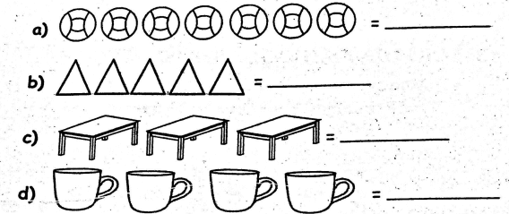
- Write the missing numbers (3mks) a. 66, 67, , , 70
b. 19, , , , 23, 24
c. 27, , 29, , 31
- Write the numbers in figures (4mks)
  - Twenty one
  - Seven
  - Thirteen
  - Fifty six
- Complete the following (4mks) a.
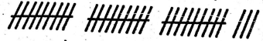
Tens, ones =
- 32 = tens and ones.
- 21 = tens and ones.
- 4 = tens and ones.
- Work out (4mks)
a. 3 + 4 + 4=
b. 8 +1 =
c. 6 + 0 =
d. 2 + 3 + 4 =

- Add (4mks)
a. 40 + 30 =
b. 50 + 10 =
c. 3 + 3 + 6 =
d. 12 + 14 =
- Fill in the boxes (2mks) a. 8 + = 12
b. + 8 = 10
- Take away (5mks)
a. 42 - 31 =
b. 13 - 5 =
c. 18 - 8 =
d. 15 - 3 =
e. 12 - 6 =
- What is 16 take away 9?
- Subtract 8 from 20
- Mark had 6 mangoes. He ate two mangoes. How many mangoes remained?(1mk)
- Which one holds more? (1mk)
- How much money? (3mks)
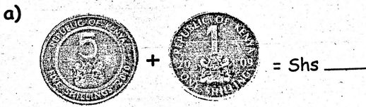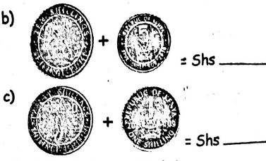
- Which line is shorter (1 mks) A
B
- A week has days. (1 mk)

