INTEGRATED LEARNING AREAS - CBC GRADE 1 TERM 1 EXAM 2023
QUESTIONS
HYGIENE & NUTRITION ACTIVITES. (10mks)

- Milk teeth are also called teeth. (1mk)
- Write one healthy habit
- Name the following forms of medicine. (2mks)
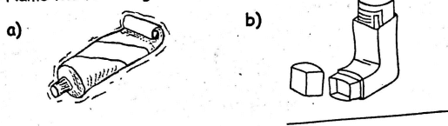
- We cut our nails short using a
- are used by boys and men. (1 mk)
- We should the toilet after using it. (1mk)

- Name the two mains sources of food. (Zmks)
- A ripe tomato is in colour. (1mk)

ENVIRONMENTAL ACTIVITIES. (10mks)

- Kites fly well on a day. (1mk)
- Name two sources of water. (2mks)
- Name the parts of the plant shown below. (2mks)
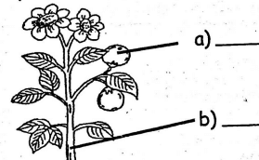
- List two domestic animals. (2mks)

- A guitar produces sound by (1mk)
- We eat the of a cabbage plant. (1mk)
- Animals that live in the forest are called animals. (1mk)

RELIGIOUS EDUCATION ACTIVITIES. (10mks)

- Father, mother and children make a family. (1mk)
- is our father in heaven. (1mk)
- The is the word of God. (1mk)
- Name the first book in the Bible (1mk)
- The father of David was called (1mk)
- Joseph had brothers. (1mk)
- Jesus was born in the town of (1mk)
- was taken to heaven by a strong wind. (1mk)
- The first people to visit baby Jesus were the (1mk)
- Draw and colour a Bible (1mk)

MOVEMENT AND CREATIVE ACTIVITIES. (10mks)

- Name two materials that are used for making a painting brush. (2mks)
- Draw the following lines. (2mks)
- Zigzag line
- Spiral line
- The smoothness or roughness of a surface is known as (1mk)
- Name three tools that are used in drawing. (3mks)

MUSIC (10mks)

- Clothes worn during a music performance are called (1mk)
- Name three types of songs. (3mks)
- A shaker is played by it. (1mk)
- When do we sing the National Anthem? (2mks)

