Hygiene and Nutrition - Grade 1 Term 1 Exam 2023
- We use our 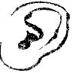 ________ to hear ( ear, nose)
- We use our 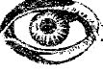 ________ to hear ( ear, eye)
Match the materials used for washing hands
- 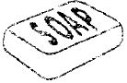 Towel
- 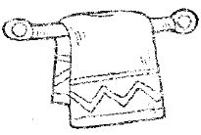 Water
- 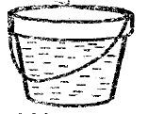 Soap
- We comb our hair using a _______(comb, towel)
- Which food destroys our teeth? __________(sweet, carrot)
- We get tomatoes from the _________( butchery, market)
- This is a _________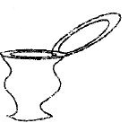 ( toilet, Urinal)
- Dirty toilets keep __________(flies, ants)
- After using toilets we should____________(flush, knock)
Write the name of the foods
- ________________
- 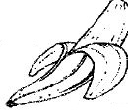
__________________
- 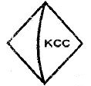
__________________
- 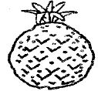
___________________
(orange, banana, pineapple, milk)
- We should _________ fruits before eating(cut, wash)
- Talking while eating is _____manners( bad, good)
- We should wash our hands______eating( before, after)
- We should_________ the table after eating( dirty, clean)_
- We use ______ to brush teeth( comb, toothbrush)
- We should not __________ food from someone's mouth( throw, eat)
- Food help us to ________( sick, grow)
- We should ___________our mouths while coughing ( wash, cover)
- We use __________ in the toilet ( soap, tissue paper)
- I wash my body with _________ and soap( tea, water)
- We should brush our ________ after eating( nose, teeth)
Draw and colour fruits you know

.

.

.

.

.

.

- I have _____ eyes ( 2, 4)
- Rotten eggs smell __________(good, bad)
- Rubbish is kept in the _________( store, dustbin)
- We should wash our ________after visiting the toilets( hands, face)
- ____________ makes our teeth strong ( sugarcane, pipes)
- Healthy teeth are ________in colour ( brown, white)

