Environmental Activities and Religious Education - Grade 1 Term 1 Exam 2023
Draw and colour things found in the kitchen

Name the colours of the national flag
- ___________________
- ___________________
- ___________________
- ___________________
Name the parts of a plant
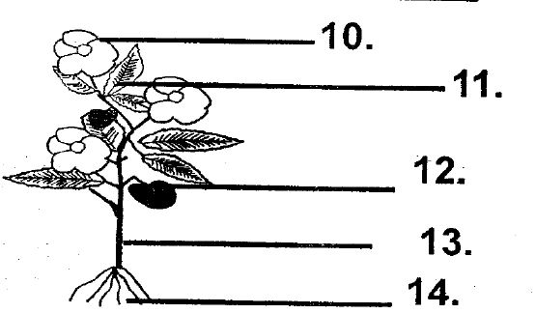
- ___________________
- ___________________
- ___________________
- ___________________
- ___________________
Draw and name two domestic animals

- _________________ is the best soil for modeling.( clay, sand)
- Plants give us_______( wool, food)
- __________ is the main source of water. (river, rain)
- We carry an ________ on a rainy day.(gumboot, umbrella)
- We drink water using a _________( glass, jug)
SECTION II
RELIGIOUS ACTIVITIES
Draw things God created
- Sun
- Moon

- Star
- Tree

- God is _________(good, bad)
Name members of the family
- ________________________
- ________________________
- ________________________
- ________________________
- I am a child of ____________( God, satan)
- We go to church to _____________( play, pray)
- The mother of Jesus was ___________( joseph, mary)

Draw and colour a church

- Jesus died on the __________( tree, cross)
- Church us the house of __________(pastor, God)
- God is happy when we __________our neighbours( love, hate)
- It is good to _________teachers ( obey, fight)

