English Activities - CBC Grade 1 Term 1 Exams 2023 SET 2
QUESTIONS
- Read aloud
I am a boy. My name is Tom. I am six years old. I have my pet. My pet is a fat cat. My cat plays with a ball. My pet is happy
- LISTENING AND SPEAKING
Answer the questions below
  - My mother is______
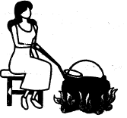
  - The boy is______the tea.
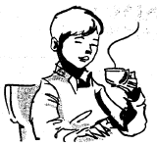
  - The girl is______
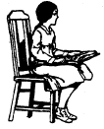
  - The girls are______the rope
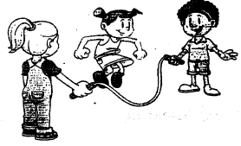

- Read the story and answer the questions
Tom has a new blue bike. He want to see Mary. She is sick. So on Tuesday morning he woke up early. He brushed his teeth, bathed and wiped his body with a towel. After dressing he took tea fast and was ready to go. He takes his hen. He put it on back of his bike. Then he rides to Mary. The hen clucks and Tom laughs. They have fun.
  - Which colour was Tom's bike?
  - Tom wants to see?
  - ______is sick
  - Write two things done by Tom after waking up
  - After dressing Tom did what
  - Tom put his hen on the______of his______
  - The hen ______and Tom______
- Language structure and grammar
Write in small letters
  - TEACHER
  - SCHOOL
  - BOY
  - FLOWER
  - POT
- Write the plural
boy
teacher
flower
man
house
- Write opposite
bottom
cold
dark
good
- My school is called?
- Write the words read by the teacher

MARKING SCHEME

  - cooking
  - drinking
  - sitting
  - skipping

  - blue
  - Mary
  - Mary
  - brush teeth
bath
  - Take tea
  - back, bike
  - clucks, laughs

  - teacher
  - school
  - boy
  - flower
  - pot
- boys
teachers
flowers
men
houses
- top
hot
light
bad

