ENVIRONMENTAL ACTIVITIES - CBC GRADE 1 TERM 1 2023
- Name these items that produce sound when hit, blown or plucked., (3mks)
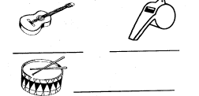
- Match the pictures with the sound that alert us on danger (5mks)
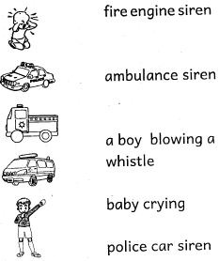
- Draw and colour these things found at home. (4mks)
CUP | TABLE

- Name these basic needs. (3mks)
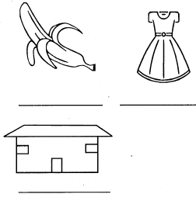
- We go to school to (learn, pray)_________________________________________
- Name the objects seen in the sky (rainy, cloudy, moon,stars,sun)
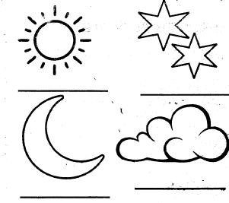
- The flowers are watered (morning and evening, night and noon)___________________________________

