GRADE 1
C.R.E ACTIVITIES 2023 TERM 1
- We should avoid _______________trees (cutting, planting0
- I am child of _________________(God, Satan )
- Sharing is ____________________(stealing, caring)
- Draw Jacobs coat of many colours and colour.

- Fill in
A. J___s____s B. S____t____n C. El___jah
- Draw , name and colour one fruit that God created

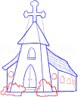
- This is a house of ______________ (prayer, sleeping)
- Write your name on the palm below

- We all have _____________________(money, names)
- Draw David and Goliath

- David was the son of _______________(Jesse, Jacob)
- Joseph was the son of __________and __________(Rachel and Jacob, Safina and Abdul)
- Name the following creations of God
a.
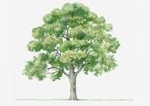________________________

b.

________________________

c.

______________________

- Who healed Simon Peter's mother-in-law? (God, Jesus, John)
- Jesus attended the wedding at Cana of ................................ (Jerusalem, Jericho, Galilee)
- Jesus attended the wedding with his ................................ and ................................
- Jesus asked the servants to fill ................................ jars with water.(4, 3, 6)

