CHAPTER SIX
MAINS ELECTRICITY
Sources of mains electricity
Mains electricity comes from a power station and its current is the alternating current which can either be stepped up or down by a transformer. A.c is produced when a conductor is rotated in a magnetic field or when a magnetic field is rotated near a conductor. This method is known as electromagnetic induction. The source of energy for rotating the turbine is the actual source of electrical energy. Most of the electricity in East Africa is generated from water.
Power transmission
This is the bulk transfer of electric power from one place to another. A power transmission system in a country is referred to as the national grid. This transmission grid is a network of power generating stations, transmission circuits and sub-stations. It is usually transmitted in three phase alternating current.
Grid input
At the generating plant the power is produced at a relatively low voltage of up to 25 kV then stepped up by the power station transformer up to 400 kV for transmission. It is transmitted by overhead cables at high voltage to minimize energy losses. The cables are made of aluminium because it is less dense than copper. Metallic poles (pylons) carry four cables, one for each phase and the fourth is the neutral cable which is thinner and completes the circuit to the generator.
Grid exit
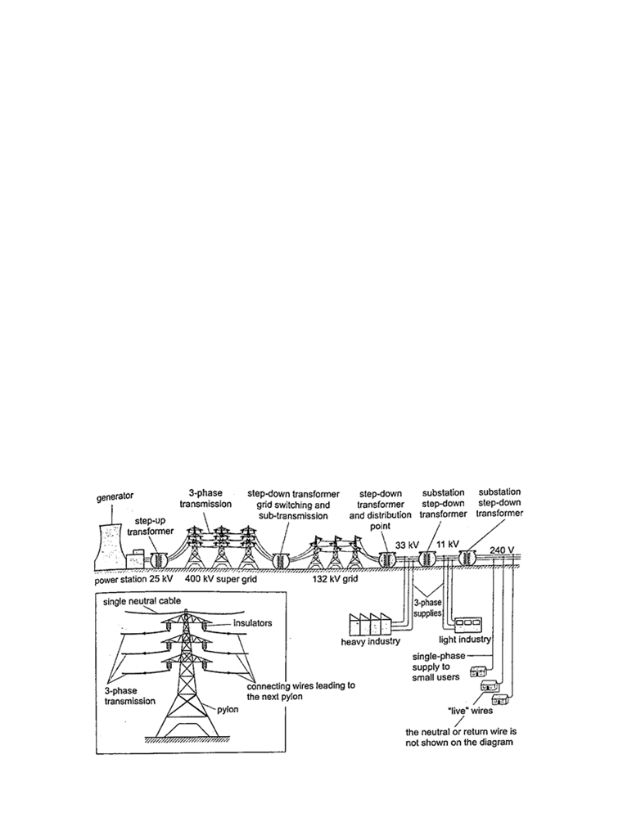
At sub-stations transformers are used to step down voltage to a lower voltage for distribution to industrial and domestic users. The combination of sub-transmission (33 kV to 132 kV) and distribution (11 kV to 33 kV) which is then finally transformed to a voltage of 240 V for
domestic use.

Electricity distribution
This is the penultimate process of delivery of electric power . It is considered to include medium voltage (less than 50 kV) power lines, low voltage (less than 1,000 V) distribution, wiring and sometimes electricity meters.

Dangers of high voltage transmission
1. They can lead to death through electrocution
2. They can cause fires during upsurge
3. Electromagnetic radiations from power lines elevate the risk of certain types of cancer

Electrical power and energy
Work done = volts × coulombs = VQ, but Q = current × time = I t. So work done = V I t
Other expressions for work may be obtained by substituting V and I from Ohms law as below V = I R and I = V / R, work done = I R × I t = I² R t, or work done = V × V t / R = V² t / R.
The three expressions can be used to calculate work done. Electrical power may be computed from the definition of power. Power = work / time = I² R t /t = I² R or V² t / R t = V² / R
Using work done = V I t, then Power = V I.
These expressions are useful in solving problems in electricity. Work done or electrical energy is measured in joules (J) and power is measured in watts (W). 1 W = 1 J/s.

Example
An electric heater running on 240 V mains has a current of 2.5 A.
a) What is its power rating?
b) What is the resistance of its element?
Solution
a) Power = V I = 240 × 2.5 = 600 W. Rating is 600 W, 240 V.
b) Power = V / R = 600 W. R = V / I. R = 240 / 2.5 = 96 Ω.

Costing electricity
The power company uses a unit called kilowatt hour (kWh) which is the energy transformed by a kW appliance in one hour. 1 kW = 1,000 W × 60 × 60 seconds = 3,600,000 J. The meter used for measuring electrical energy uses the kWh as the unit and is known as joule meter.
Examples
1. An electric kettle is rated at 2,500 W and uses a voltage of 240 V.
a) If electricity costs Ksh 1.10 per kWh, what is the cost of running it for 6 hrs?
b) What would be its rate of dissipating energy if the mains voltage was dropped to 120 V?

Solution
a) Energy transformed in 6 hrs = 2.5 × 6 = 15 kWh. Cost = 15 × 1.10 × 6 = Ksh 99.00
b) Power = V² / R = 2500. R = (240 × 240) /2500 = 23.04 Ω.
Current = V / R = (240 × 2500) / (240 × 240) = 10.42 A Power = V I = (2500 × 120) / 240 = 1,250 W.
2.An electric heater is made of a wire of resistance 100 Ω connected to a 240 V mains supply. Determine the;
a) Power rating of the heater
b) Current flowing in the circuit
c) Time taken for the heater to raise the temperature of 200 g of water from 23⁰C to 95⁰C. (specific heat capacity of water = 4,200 J Kg⁻¹ K⁻¹)
d) Cost of using the heater for two hours a day for 30 days if the power company charges Ksh 5.00 per kWh.
Solution
a) Power = V² / R = (240 × 240) / 100 = 576 W
b) P = V I =>> I = P / V = 576 / 240 = 2.4 A
c) P × t = heat supplied = (m c θ) = 576 × t = 0.2 × 4200 × 72.
Hence t = (0.2 × 4200 × 72) / 576 = 105 seconds.
d) Cost = kWh × cost per unit = (0.576 × 2 × 30) × 5.0 = Ksh 172.80
3.A house has five rooms each with a 60 W, 240 V bulb. If the bulbs are switched on fro7.00 pm to 10.30 pm, calculate the;
a) Power consumed per day in kWh
b) Cost per week for lighting those rooms if it costs 90 cents per unit.
Solution
a) Power consumed by 5 bulbs = 60 × 5 = 300 W = 0.3 kWh. Time = 10.30 - 7.00 = 3 ½ hrs.Therefore for the time duration = 0.3 × 3 ½ = 1.05 kWh.
b) Power consumed in 7 days = 1.05 × 7 = 7.35 kWh. Cost = 7.35 × 0.9 = Ksh 6.62

Domestic wiring system
Power is supplied by two cables where one line is live wire (L) and the other is neutral (N).
Domestic supply in Kenya is usually of voltage 240 V. The current alternates 50 times per second hence the frequency is 50 Hz. The neutral is earthed to maintain a zero potential. The main fuse is fitted on the live wire to cut off supply in case of a default. A fuse is a short piece of wire which melts if current of more value flows through it. Supply to the house is fed to the joule meter which measures the energy consumed. From the meter both L and N cables go to
the consumer box (fuse box) through the main switch which is fitted on the live cable.
Consumer units within the house are fitted with circuit breakers which go off whenever there is a default in the system. Lights in the house are controlled by a single or double switch (two way). In most wiring systems the main sockets are connected to a ring main which is a cable
which starts and end at the consumer unit. Plugs used are the three- pin type.
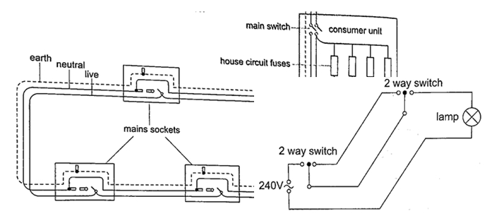

CHAPTER SEVEN
CATHODE RAYS
These are streams of electrons emitted at the cathode of an evacuated tube containing an anode and a cathode.

Production of cathode rays
They are produced by a set up called a discharge tube where a high voltage source usually referred to as extra high tension (EHT) supply connected across a tube conta-ining air at low pressure thereby producing a luminous electron discharge between the two brass rods placed at opposite ends of the tube. These electron discharges are called cathode rays which were discovered by J.J Thomson in the 18th century.
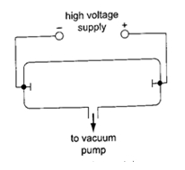

Properties of cathode rays
1. They travel in straight lines
2. They are particulate in nature i.e. negatively charged electrons
3. They are affected by both magnetic and electric fields since they are deflected towards the positive plates
4. They produce fluorescence in some materials
5. Depending on the energy of the cathode rays they can penetrate thin sheets of paper, metal foils
6. When cathode rays are stopped they produce X-rays.
7. They affect photographic plates.

Cathode ray oscilloscope (CRO)

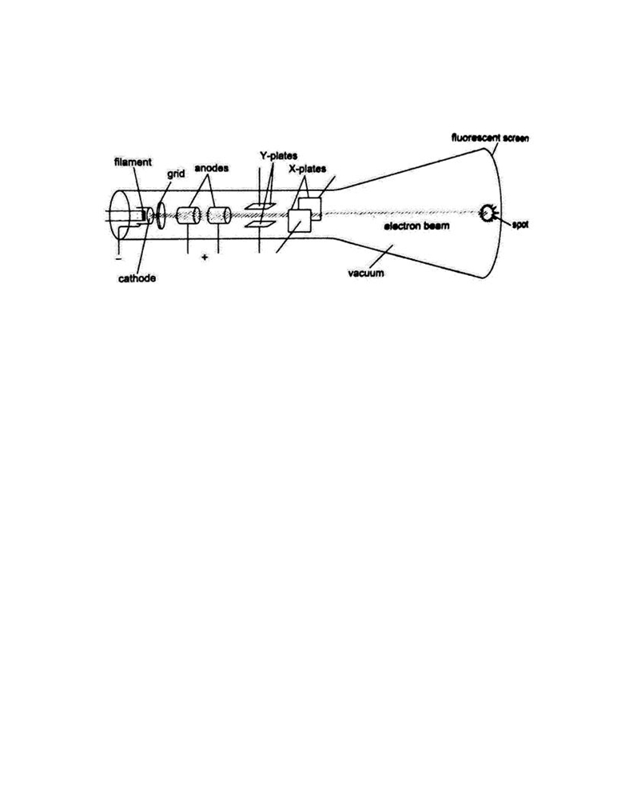
It is a complex equipment used in displaying waveforms from various sources and measuring
p.d. It comprises of the following main components; - The cathode ray tubes (CRT) - consists of
a tube, electron gun, deflection plates and the time base (TB). The tube is made of strong glass
to

withstand the pressure difference between the outside atmospheric pressure and the vacuum inside. It has a square grid placed in front of it to allow measurements to be made. The electron
gun produces the electrons with main parts consisting of a filament, a cathode, a grid and the anode. Electrons are produced by the cathode when heated by the filament. The grid is a control electrode which determines the number of electrons reaching the screen therefore determining the brightness of the screen. The Y-deflection plates deflects the beam up or down. Clearly observable when low frequency inputs are applied i.e. 10 Hz from a signal operator. The X-deflection plates are used to move the beam left or right of the screen at a steady speed using the time base circuit which automatically changes voltage to an a.c. voltage.
When time base control is turned the speed can be adjusted to produce a waveform.
Examples
1. If the time base control of the CRO is set at 10 milliseconds per cm, what is the frequency of the wave traced given wavelength as 1.8 cm?
Solution
Wavelength = 1.8 cm. time for complete wave = period = 1.8 × 10 milliseconds / cm
= 18 milliseconds
= 1.8 × 10⁻² seconds.
Frequency ‘f’, is given by f = 1 / T = 1 / 1.8 × 10⁻² = 100 / 1.8 = 56 Hz.
NOTE: -
The television set (TV) is a type of a CRT with both Y and X-deflection plates which control the
formation of a picture (motion) on the screen. The colour television screen is coated with different phosphor dots (chemicals) which produce a different colour when struck by an electron beam.
CHAPTER EIGHT
X-RAYS
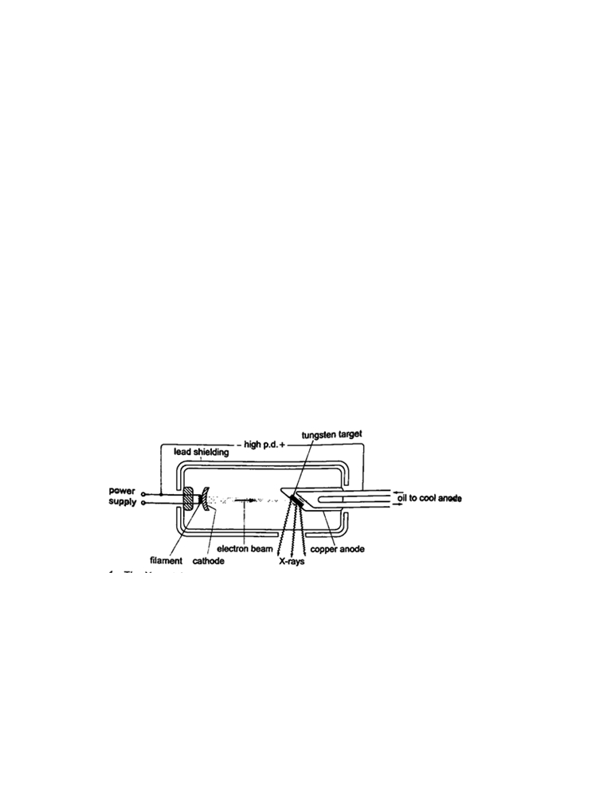
X-rays were discovered by a German scientist named Roentgen in 1985. They can pass through most substances including soft tissues of the body but not through bones and most metals. They were named X-rays meaning 'unknown rays'.
X-ray production
They are produced by modified discharge tubes called X-ray tubes. The cathode is in the form of a filament which emits electrons on heating. The anode is made of solid copper molybdenum and is called the target. A high potential difference between the anode and the cathode is maintained (10,000 v to 1,000,000 or more) by an external source. The filament is made up of tungsten and coiled to provide high resistance to the current. The electrons produced are
changed into x-rays on hitting the anode and getting stopped. Only 0.2% of the energy is converted into x-rays. Cooling oil is led in and out of the hollow of the anode to maintain low
temperature. The lead shield absorbs stray x-rays.

Energy changes in an X-ray tube.
When the cathode is heated electrons are emitted by thermionic emission. They acquire electrical energy which can be expressed as E = e V. Once in motion the electrical energy is converted to kinetic energy, that is eV = ½ m_{e} v².
The energy of an electromagnetic wave can be calculated using the following equation Energy = h f, where h- Planck’s constant, f - frequency of the wave.
The highest frequency of the X-rays released after an electron hits the target is when the greatest kinetic energy is lost, that is h f _{max} = eV.
Lower frequencies are released when the electrons make multiple collisions losing energy in stages, the minimum wavelength, λ _{min}, of the emitted X-rays is given by;
(hc) / λ _{min} = eV.
These expressions can be used to calculate the energy, frequencies and wavelengths of X-rays.
Examples
1.Determine the energy possessed by X-rays whose frequency is 4 × 10¹⁷ Hz.
Solution
E = h f => 6.63 × 10⁻³⁴ ×4 × 10¹⁷ = 2.652 × 10⁻¹⁶ J.
2. An x-ray tube operates at 60 kV and the current through it is 4.0 mA. Calculate the,
a) Number of electrons striking the target per second.
b) Speed of the electrons when they hit the target.
Solution
a) Current through the tube is given by I = ne, where n- number of electrons striking target per second and e-electronic charge ( e = 1.6 × 10⁻¹⁹coulombs)
So, n = 1/e = (4.0 × 10⁻³) / 1.6 × 10⁻¹⁹ = 2.5 × 10¹⁶ electrons.
b) Kinetic energy = electrical energy
½ m_{e} v² = eV, then v = √ = √ = 2.13 × 10⁸ m/s.
3. An 18 kV accelerating voltage is applied across an X-ray tube. Calculate;
a) The velocity of the fastest electron striking the target
b) The minimum wavelength in the continuous spectrum of X-rays produced. (mass of electron-9 × 10⁻³¹ kg, charge on an electron-1.6 × 10⁻¹⁹ C, h- 6.6 × 10⁻³⁴ J/s, c- 3 × 10⁸ m/s)
Solution
a) V = 18 × 10³ V
me = 9 × 10⁻³¹ kg
e = 1.6 × 10⁻¹⁹ C
h = 6.6 × 10⁻³⁴ J/s
c = 3 × 10⁸ m/s
½ m_{e} v² = e v; therefore v = √ = √ = 8 × 10⁷ m/s’
b)(h c) / λ _{min} = eV; λ _{min} = hc / eV
λ _{min} = (6.6 × 10⁻³⁴× 3 × 10⁸ ) / (1.6 × 10⁻¹⁹× 18 × 10³) = 6.9 × 10⁻¹¹ m.
Properties of X-rays
i)They travel in straight lines
ii)They undergo reflection and diffraction
iii)They are not affected by electric or magnetic fields since they are not chargedparticles.
iv)They ionize gases causing them to conduct electricity
v)They affect photographic films
vi)They are highly penetrating, able to pass easily through thin sheets of paper, metal foils and body tissues
vii) They cause fluorescence in certain substances for example barium platinocynide.

Hard X-rays
These are x-rays on the lower end of their range (10⁻¹¹ - 10⁻⁸ m) and have more penetrating power than normal x-rays. They are capable of penetrating flesh but are absorbed by bones.

Soft X-rays
They are on the upper end of the range and are less penetrative. They can only penetrate soft flesh and can be used toshow malignant growth in tissues.

Dangers of X-rays and the precautions
1. They can destroy or damage living cells when over exposed.
2. Excessive exposure of living cells can lead to genetic mutation.
3. As a precautionary measure X-ray tubes are shielded by lead shields.

Uses of X-rays
1. Medicine - X-ray photos called radiographs are used as diagnostic tools for various diseases. They are also used to treat cancer in radiotherapy.
2. Industry - they are used to photograph and reveal hidden flaws .i.e. cracks in metal casting and welded joints.
3. Science - since the spacing of atomic arrangement causes diffraction of x-rays then their structure can be studied through a process called X-ray crystallography.
4. Security - used in military and airport installations to detect dangerous metallic objects .i.e. guns, explosives, grenades etc.

CHAPTER NINE
PHOTOELECTRIC EFFECT
Photoelectric effect was discovered by Heinrich Hertz in 1887. Photoelectric effect is a phenomenon in which electrons are emitted from the surface of a substance when certain electromagnetic radiation falls on it. Metal surfaces require ultra-violet radiation while caesium oxide needs a visible light i.e. optical spectrum (sunlight).

Work function
A minimum amount of work is needed to remove an electron from its energy level so as to overcome the forces binding it to the surface. This work is known as the work function with units of electron volts (eV). One electron volt is the work done when one electron is
transferred between points with a potential difference of one volt; that is,
1 eV = 1 electron × 1 volt
1 eV = 1.6 × 10⁻¹⁹ × 1 volt
1 eV = 1.6× 10⁻¹⁹ Joules (J)

Threshold frequency
This is the minimum frequency of the radiation that will cause a photoelectric effect on a certain surface. The higher the work function, the higher the threshold frequency.

Factors affecting the photoelectric effect
1. Intensity of the incident radiation- the rate of emission of photoelectrons is directly proportional to the intensity of incident radiation.
2. Work function of the surface- photoelectrons are emitted at different velocities with the maximum being processed by the ones at the surface.
3. Frequency of the incident radiation- the cut-off potential for each surface is directly proportional to the frequency of the incident radiation.
Planck’s constant
When a bunch of oscillating atoms and the energy of each oscillating atom is quantified i.e. it could only take discrete values. Max Planck’s predicted the energy of an oscillating atom to be E = n h f, where n - integer, f - frequency of the source, h - Planck’s constant which has a value of 6.63 × 10⁻³⁴ Js.

Quantum theory of light
Planck’s published his quantum hypothesis in 1901 which assumes that the transfer of energy between light radiation and matter occurs in discrete units or packets. Einstein proposed that light is made up of packets of energy called photons which have no mass but they have
momentum and energy given by; E = h f
The number of photons per unit area of the cross -section of a beam of light is proportional to its intensity. However the energy of a photon is proportional to its frequency and not the
intensity of the light.

Einstein’s photoelectric equation

As an electron escapes energy equivalent to the work function ‘Φ’ of the emitter substance is given up. So the photon energy ‘h f’ must be greater than or equal to Φ. If the ‘h f’ is greater than Φ then the electron acquires some kinetic energy after leaving the surface. The maximum kinetic energy of the ejected photoelectron is given by;
K.E _{max} = ½ m v^{2max} = h f - Φ ……………… (i), where m v^{2max} = maximum velocity and mass. This is the Einstein’s photoelectric equation.
If the photon energy is just equivalent to work function then, m v^{2max} = 0, at this juncture the electron will not be able to move hence no photoelectric current, giving rise to a condition known as cut-off frequency, h f_{co} = Φ………………. (ii)
Also the p.d required to stop the fastest photoelectron is the cut-off potential, V _{co}which is given by E = e V _{co} electron volts, but this energy is the maximum kinetic energy of the photoelectrons and therefore, ½ m v^{2max} = e V _{co} ………….. (iii).
Combining equations (i), (ii) and (iii), we can write Einstein’s photoelectric equation as, e V _{co} = h f - h f_{co} ………………….. (iv)
NOTE: -- Equations (i) and (iv) are quite useful in solving problems involving photoelectric effect.
Examples
1.The cut-off wavelength for a certain material is 3.310 × 10⁻⁷ m. What is the cut-off frequency for the material?
Solution
Speed of light ‘c’ = 3.0 × 10⁸ m/s. Since f = c / λ, then f = 3.0 × 10⁸ / 3.310 × 10⁻⁷ = 9.06 × 10¹⁴ Hz.
2. The work function of tungsten is 4.52 e V. Find the cut-off potential for photoelectrons when a tungsten surface is illuminated with radiation of wavelength 2.50 × 10⁻⁷ m. (Planck’s constant, h = 6.62 × 10⁻³⁴ Js).
Solution
Frequency ‘f’ = c / λ = 3.0 × 10⁸ / 2.50 × 10⁻⁷.
Energy of photon = h f = 6.62 × 10⁻³⁴ × (3.0 × 10⁸ / 2.50 × 10⁻⁷) × (1 / 1.6 × 10⁻¹⁹) = 4.97 eV.
Hence h f_{co} = 4.52 e V. e V _{co} = 4.97 e V - 4.52 e V = 0.45 e V = 7.2 × 10⁻²⁰ J V _{co} = 7.2 × 10⁻²⁰ / 1.6 × 10⁻¹⁹ = 0.45 e V.
3.The threshold frequency for lithium is 5.5 × 10¹⁴ Hz. Calculate the work function for lithium. (Take‘h’ = 6.626 × 10⁻³⁴ Js)
Solution
Threshold frequency, f _{o} = 5.5 × 10¹⁴ Hz, ‘h’ = 6.626 × 10⁻³⁴ Js
Φ = h f = 5.5 × 10¹⁴× 6.626 × 10⁻³⁴ = 36.4 × 10⁻²⁰
4. Sodium has a work function of 2.0 e V. Calculate
a) The maximum energy and velocity of the emitted electrons when sodium is Illuminated by a radiation of wavelength 150 nm.
b) Determine the least frequency of radiation by which electrons are emitted.
(Take ‘h’ = 6.626 × 10⁻³⁴ Js, e = 1.6 × 10⁻¹⁹, c = 3.0 × 10⁸ m/s and mass of electron = 9.1 × 10⁻³¹ kg).
Solution
a) The energy of incident photon is given by h f = c / λ
= (6.626 × 10⁻³⁴ × 3.0 × 10⁸) / 1.50 × 10⁻⁹ = 1.325 × 10⁻¹⁸ J

K.E _{max} = h f - Φ = (1.325 × 10⁻¹⁸) - (2 × 1.6 × 10⁻¹⁹) = 1.0 × 10 ⁻¹⁸ J (max. K.E of the emitted electrons)
But K.E _{max} = ½ m v^{2max}. Therefore; 1.0 × 10 ⁻¹⁸ = ½ × 9.1 × 10⁻³¹ × V^{2max}
V^{2max} = (1.0 × 10 ⁻¹⁸ / 9.1 × 10⁻³¹)^{1/2} = 1.5 × 10⁶ m/s (max. velocity of emitted electrons).
b) Φ = h f _{co} and f _{o} = Φ / λ, Φ = 2 × 1.6 × 10⁻¹⁹
f_{o} = (2 × 1.6 × 10⁻¹⁹) / (6.626 × 10⁻³⁴) = 4.8 × 10¹⁴ Hz (min. threshold frequency of the emitted electrons)

Applications of photoelectric effect
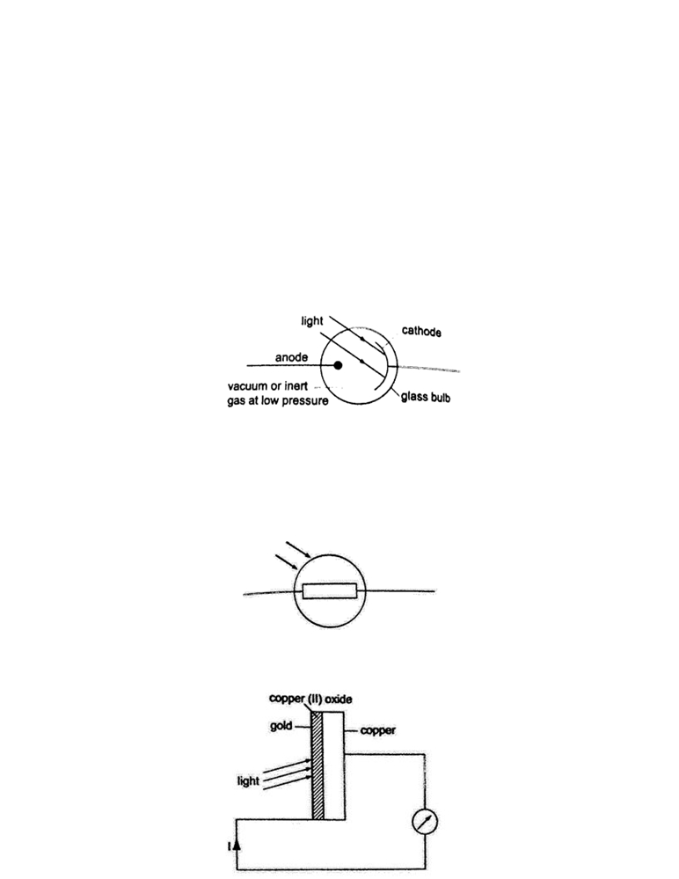
1. Photo-emissive cells- they are made up of two electrodes enclosed in a glass bulb (evacuated or containing inert gas at low temperature). The cathode is a curved metal plate while the anode is normally a single metal rod)

They are used mostly in controlling lifts (doors) and reproducing the sound track in a film. Photoconductive cells - some semi-conductors such as cadmium sulphide (cds) reduces their resistance when light is shone at them (photo resistors). Other devices such as photo-diodes and photo-transistors block current when the intensity of light increases. Photo-conductive cells are also known as light dependent resistors (LDR) and are used in alarm circuits i.e. fire alarms, and also in cameras as exposure metres.

2. Photo-voltaic cell- this cell generates an e.m.f using light and consists of a copper disc oxidized on one surface and a very thin film of gold is deposited over the exposed surfaces (this thin film allows light). The current increases with light intensity.They are used in electronic calculators, solar panels etc.

CHAPTER TEN
RADIOACTIVITY
Introduction
Radioactivity was discovered by Henri Becquerel in 1869. In 1898, Marie and Pierre Curie succeeded in chemically isolating two radioactive elements, Polonium (z=84) and Radium (z=
88). Radioactivity or radioactive decay is the spontaneous disinter-gration of unstable nuclides to form stable ones with the emission of radiation. Unstable nuclides continue to disintegrate until a stable atom is formed.Alpha (α) and beta (ϐ) particles are emitted and the gamma rays (ϒ) accompany the ejection of both alpha and beta particles.

The nucleus
The nucleus is made up of protons and neutrons. They are surrou-nded by negatively charged ions known as electrons. The number of protons is equal to the number of electrons. Both protons and neutrons have the same mass. The weight of an electron is relatively small compared to neutrons and protons. The number of protons in an atom is referred to as the proton number (atomic number) and denoted by the symbol Z . the number of neutrons is denoted by the symbol N. Protons and neutrons are called nucleons since they form the nucleus of an atom. The sum of both the protons and neutrons is called the mass number A or nucleon number. Therefore;
A = Z + N and N = A - Z.
The masses of atoms are conveniently given in terms of atomic mass units (ᴜ) where (ᴜ) is 1/12th the mass of one atom of carbon-12 and has a value of 1.660 × 10⁻²⁷ kg. Hence the mass of one proton is equal to 1.67 × 10⁻²⁷ and is equal to 1ᴜ.

Radioactive isotopes
Isotopes are elements with different mass numbers but with equal atomic numbers i.e. uranium with mass numbers 235 and 238.

Properties of radioactive emissions
a)Alpha (α) particles
They are represented as, hence with a nucleus number 4 and a charge of +2.
Properties
1. Their speeds are 1.67 × 10⁷ m/s, which is 10% the speed of light.
2. They are positively charged with a magnitude of a charge double that of an electron.
3. They cause intense ionization hence loosing energy rapidly hence they have a very short range of about 8 cm in air.
4. They can be stopped by a thin sheet of paper, when stopped they capture two electrons and become helium gas atoms
5. They can be affected by photographic plates and produce flashes when incident on a fluorescent screen and produce heating effect in matter.
6. They are slightly deflected by a magnetic field indicating that they have comparatively large masses.
b)Beta (ϐ) particles
They are represented by meaning that they have no mass but a charge of -1.
Properties
1. Their speeds are as high as 99.9% or more the speed of light
2. They are deflected by electric and magnetic fields but in a direction opposite to that of alpha particles.
3. Due to their high speed they have a higher penetrative rate than alpha particles (about 100 times more)
4. They can be stopped by a thin sheet of aluminium
5. Their ionization power is much less intense about 1/100th that of alpha particles.
c)Gamma (ϒ) particles
They have very short wavelengths in the order of 10⁻¹⁰ m and below. Properties
1. They travel at the speed of light.
2. They have less ionization power than that of both alpha and beta particles
3. They accompany the emission of alpha and beta particles
4. They carry no electric charge hence they are not defle-cted by both electric and magnetic fields.
5. They have more penetrating power than X-rays.

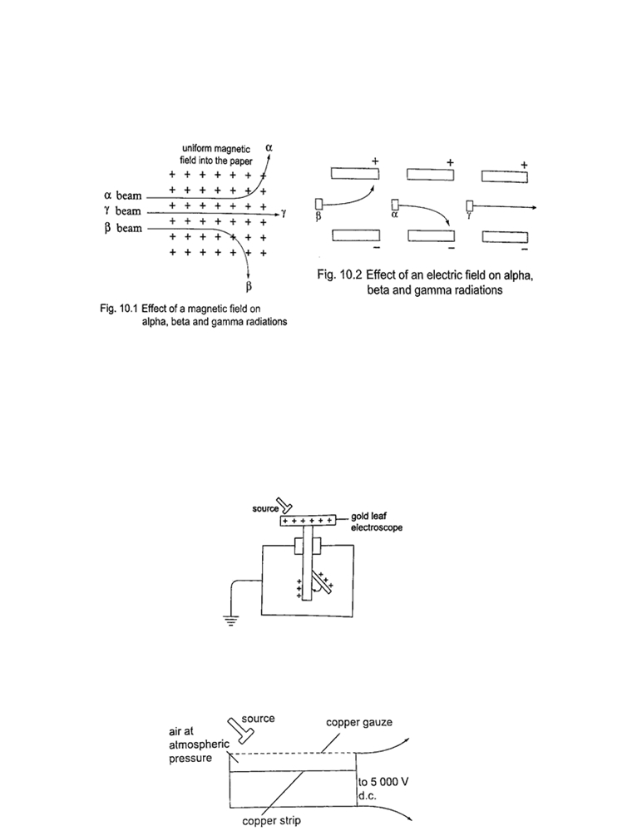

Detecting nuclear radiation
1. Gold leaf electroscope-the rate of collapse of the leaf depends on the nature and intensity of radiation. The radioactive source ionizes the air around the electroscope. Beta particles discharges a positively charged electroscope with the negative charge neutralizing the charge of the electroscope. Alpha particles would similarly discharge a negatively charged electroscope.
To detect both alpha and beta particles a charged electroscope may not be suitable because their ionization in air may not be sufficiently intense making the leaf not to fall noticeably.

2. The spark counter - the detector is shown below

This detector is suitable for alpha sources due to the inadequacy of the ionization by both beta and gamma radiations. By putting the source away from the gauze or placing a sheet of paper between the two one can determine the range and penetration of the alpha particles.

3. Geiger Muller (GM) tube- it is illustrated as below

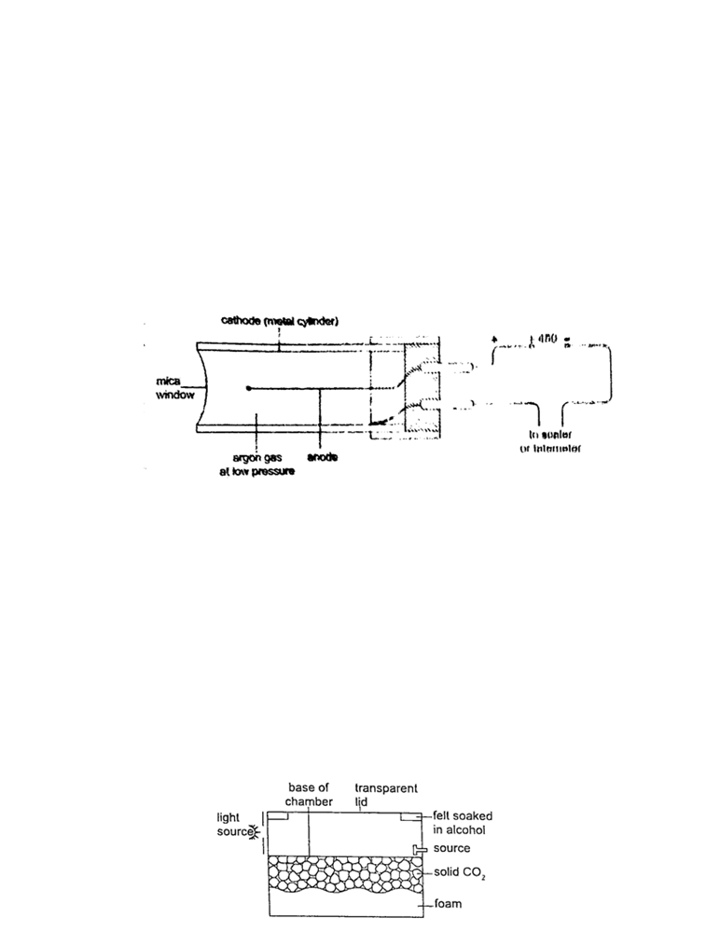

The mica window allows passage of alpha, beta and gamma radiations. The radiations ionize the gas inside the tube. The electrons move to the anode while the positive ions move to the cathode. As the ions are produced there are collisions which produce small currents which are in turn amplified and passed to the scale. The scale counts the pulses and shows the total on a display screen. After each pulse the gas returns to normal ready for the next particle to enter. A small presence of halogen gas in the tube helps in absorbing the positive ions to reduce further ionization and hence a quick return to normal. This is called quenching the tube.
4. The solid state detector- this detector can be used to detect alpha, beta and gamma radiations where the incoming radiation hits a reverse biased p-n junction diode momentarily conducting the radiation and the pulse of the current is detected using a scaler.
5. The diffusion cloud chamber- this chamber is simplified as shown below

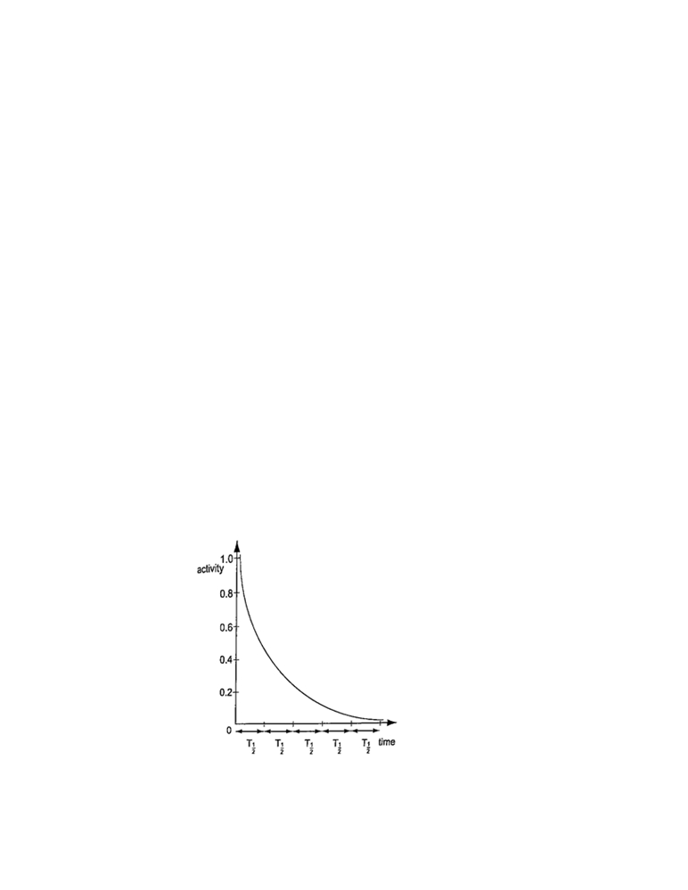
The bottom of the chamber is cooled by solid carbon (V) oxide to around -80⁰ C and the alcohol vapour from the felt ring spreads downwards. It is cooled below its normal condensing temperature. As a particle enters the chamber it ionizes the air in its path
and alcohol condenses around the path to form millions of tiny alcohol droplets leaving a trail visible because it reflects light from the source. Alpha particles leave a thick, short straight tracks. Beta particles leave thin irregular tracks. Gamma particles do not
produce tracks and since they eject electrons from atoms the tracks are similar to those of beta particles.

Activity and half-life of elements
The activity of a sample of radioactive element is the rate at which its constituent nuclei decay or disintegrate. It is measured in disinter-grations per second or Curie (Ci) units, where 1 Ci = 3.7 × 10¹⁰ disintegrations per second 1 micro Curie (µ C) = 3.7 × 10⁴ disintegrations per second.
The law of radioactive decay states that “the activity of a sample is proportional to the number of undecayed nuclei present in the sample”. The half-life of a radioactive element is the time required for its one-half of the sample to decay. It is important to note that although the activity approaches zero, it never goes to zero.

Examples
1. The half-life of a sample of a radioactive substance is 98 minutes. How long does it take for the activity of the sample to reduce to 1/16th of the original value?

Solution
Time (minutes) Activity
0 1
98 ½
196 ¼
294 1/8
392 1/16 =>> time taken = 392 minutes.

2.An isotope has a half-life of 576 hours. Complete the following table and show how mass
varies with time from an initial mass of 1280 g?
Time (hrs) 576 1152 1728 2304
Mass (g) 640

Solution
1152 ------ 320 g
1728 ------ 160 g
2304 ------ 80 g.
3. The initial number of atoms in a sample is 5.12 × 10²⁰. If the half-life of the sample is 3.0 seconds, determine the number of atoms that will have decayed after six seconds.
Solution
After the first half-life, then ½ (5.12 × 10²⁰) = 2.56 × 10²⁰ will have decayed.
The second half-life, then ½ (2.56 × 10²⁰) = 1.28 × 10²⁰ will have decayed.
The total number of decayed atoms = (2.56 + 1.28) × 10²⁰ = 3.84 × 10²⁰ atoms.
4. A radioactive element has an initial count rate of 2,400 counts per minute on a scaler. The count rate falls to 300 units per minute in 30 hours,
a) Calculate the half-life of the element
b) If the initial number of atoms in another sample of the same element is 6.0 × 10²⁰, how many atoms will have decayed in 50 hours?
Solution
a) 2,400 × ½ × ½ × ½ = 300
Three half-lives have a total of 30 hours, thus half-life = 30 /3 = 10 hours
b) Since half-life = 10 hrs half-lives in 50 hrs = 50/10 = 5 hrs.
So the remaining undecayed atoms are ½ × ½ × ½ × ½ × ½ × 6.0 × 10²⁰
= 0.1875 × 10²⁰, thus
The number of atoms which have decayed = (6.0 - 0.1875) × 10²⁰
= 5.812 × 10²⁰

Nuclear equations
Particles making an atom can be written using upper and lower subscripts where a proton, ‘p’ with charge +1 and mass 1ᴜ, is written as . A neutron ‘n’ with no charge but with mass 1ᴜ, is written as, while an electron with a charge of -1 and negligible mass is written as. It isimportant to note that the principles of conservation apply in radioactive decay. That means that the total number of nucleons (neutrons + protons) must be the same before and after decay. The L.H.S of the equation must be equal to the R.H.S for both total mass and charge.

Effects of radioactive decay on the nucleus
Alpha decay
A nucleus emitting an alpha particle reduces its mass by 4 atomic mass units and its proton number by 2. The equation can be written as follows,

----------→ + α or ----------→ +
Example
Uranium- 235 ( ) changes to Thorium (equation to represent the decay.
Solution
--------→ +

) by emitting an alpha particle. Write a nuclear

The change of an element (nucleus) to another is called transmutation.
Beta decay
The beta particle is an electron. Beta particles are produced by changing a neutron to a proton and later to an electron as shown,
--------→ +
The electron is then ejected from the nucleus and the number of protons increases by 1 while the mass number remains the same (an electron is of negligible mass).
----------→ +
Examples
1. Thorium ) changes to Proctanium (P_{o}) with the emission of a beta particle. Show the decay using nuclear equation.
Solution
----------→ o +
2. Write an equation to show how a radioactive isotope of cobalt ( o) undergoes a beta decay followed by the emission of gamma rays to form a new nuclide X.
Solution
o -------→ϐ + ϒ + or o + +ϒ +
3. A radioactive carbon-14 decays to nitrogen by emitting a beta particle as shown.
Determine the values of ‘x’ and ‘y’ in the equation below.
------→ +
Solution
X + 0 = 14 hence x = 14
7 + y =6 hence y = -1

Nuclear fission
Nuclear fission is a process in which a nucleus splits into two or more lighter nuclei . This process generates large amounts of energy together with neutron emission. Nearly 80% of the energy produced appears as kinetic energy of the fission fragments. For example Uranium-235 undergoes nuclear fission when bombarded with slow neutrons releasing 2-3 neutrons per Uranium molecule and every neutron released brings about the fission of another Uranium-
235nuclei. Another substance which undergoes the same process is Plutonium-239. Substances which undergo fission directly with slow neutrons are known as fissile substances or isotopes. Applications of nuclear fission
1. They are used in the manufacture of atomic bombs where tremendous amount of energy is released within a very short time leading to an explosion.
2. When this release of energy is controlled such that it can be released at a steady rate then it is converted into electrical energy hence the principle in nuclear reactors.

Nuclear fusion
Nuclear fusion is the thermal combining of light elements to form relatively heavier nuclei . The process requires very high temperatures for the reacting nuclei to combine upon collision. These temperatures are provided by ordinary fission bombs. These reactions sometimes known as thermonuclear reactions. A fusion reaction releases energy at the rate of 3-23 MeV per fusion event i.e. two deuterium (heavy hydrogen) nuclei to form helium.

This 3.3 MeV (energy) produced is equal to 5.28 × 10⁻¹³ J. Application of nuclear fusion
1. Used in the production of hydrogen bomb. Possible reactions for an hydrogen bomb include;

Hazards of radioactivity and their precautions

(i)Due to the ionizing radiation emitted by radiation materials, they affect living cellsleading to serious illnesses. Symptoms of radiation exposures are immature births, deformations, retardedness, etc.
(ii) Their exposure to the environment through leaks may lead to environmental pollution leading to poor crop growth and destruction of marine life.

Applications of radioactivity
1. Carbon dating - through the identification of carbon-14 and carbon-12 absorbed by dead plants and animals. Scientists can be able to estimate the age of a dead organism. Since carbon is a radioactive element with a half-life of 5,600 years archeologists can be able to estimate the ages of early life through carbon dating.
2. Medicine - radiation is used in the treatment of cancer, by using a radioactive cobalt-60 to kill the malignant tissue. Radiations are used in taking x-ray photographs using cobalt-60. Radiations are used to sterilize surgical instruments in hospitals. Radioactive elements can also be used as tracers in medicine where they determine the efficiency of organisms such as kidneys and thyroid glands.
3. Biology and agriculture - radioactive sources are used to generate different species of plants with new characteristics that can withstand diseases and drought. Insects are sterilized through radiation to prevent the spread of pests and diseases. Potatoes exposed to radiation can be stored for a long time without perishing.
4. Industry - thickness of metal sheets is measured accurately using radiation from radioactive sources. Recently the manufacture of industrial diamonds is undertaken through transmutation.
5. Energy source - in N. America, Europe and Russia nuclear reactors are used to generate electricity. The amount of fuel used is quite small hence an economical way of generating electricity energy as compared to H.E.P generation.

CHAPTER ELEVEN
ELECTRONICS

Conductors, insulators and semi-conductors
i)An insulator is a material or object which resists flow of heat (thermal insulator) or electrical charges (electrical insulators). Examples are paraffin, wood, rubber, plastics etc.

ii)Conductor are materials that contain free electrons which carry an electrical charge from one point to another. Examples are metals and non-metals like carbon, graphite etc.
iii) Semi-conductors are materials or objects which allow the flow of electrical heat or energy through them under certain conditions i.e. temperature. Examples are germanium, silicon, cadmium sulphide, gallium arsenide etc.

Electronic bond structure
This is the series of “allowed” and “forbidden” energy bands that it y bands that it contains according to the band theory which postulates the existence of continuous ranges of energy values (bands) which electron may occupy “allowed” or not occupy ‘forbidden”. According to molecular orbital theory, if several atoms are brought together in a molecule, their atomic orbitals split, producing a number of molecular orbitals proportional to the number of atoms.
However when a large number of atoms are brought together the difference between their energy levels become very small, such that some intervals of energy contain no orbitals and this theory makes an assumption that these energy levels are as numerous as to be indistinct.
Number, size and spacing of bands
Any solid has a large number of bands (theoretically infinite). Bands have different widths based upon the properties of the atomic orbitals from which they arise. Bands may also overlap to produce a bigger single band.
Valence and conduction bands
Valence band is the highest range of electron energies where electr-ons are normally present at zero temperature. Conduction band is the range of electron energy higher than that of the valence band sufficient to make electrons free (delocalized); responsible for transfer of electric charge. Insulators and semi-conductors have a gap above valence band followed by conduction band above it. In metals, the conduction band is the valence band.

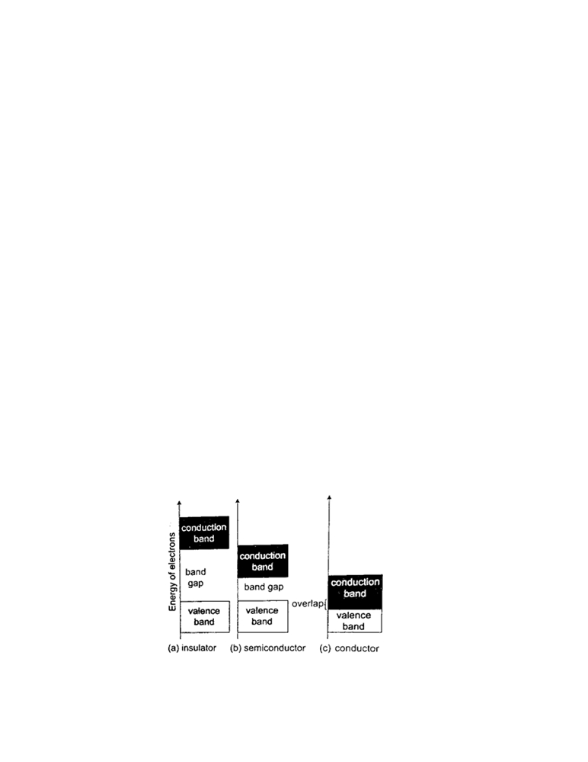

Band structure of a semi-conductor
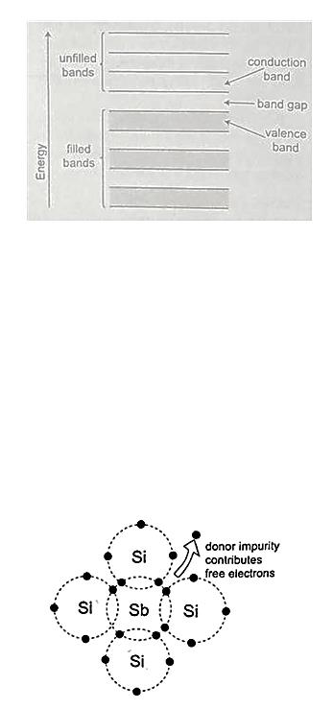
Electrons in the conduction band break free of the covalent bonds between atoms and are free to move around hence conduct charge. The covalent bonds have missing electrons or ‘holes’ after the electrons have moved. The current carrying electrons in the conduction band are
known as free electrons.

Doping of semi-conductors
Doping is the introduction of impurities in semi-conductors to alter their electronic properties. The impurities are called dopants. Doping heavily may increase their conductivity by a factor greater than a million.
Intrinsic and extrinsic semi-conductors
An intrinsic semi-conductor is one which is pure enough such that the impurities in it do not significantly affect its electrical behavior. Intrinsic semi-conductors increase their conductivity with increase in temperature unlike metals.An extrinsic semi-conductor is one which has been doped with impurities to modify its number and type of free charge carriers present.

N-type semi-conductors
In this case the semi-conductor is given atoms by an impurity and this impurity is known as donor so it is given donor atoms (donated).

P-type semi-conductors
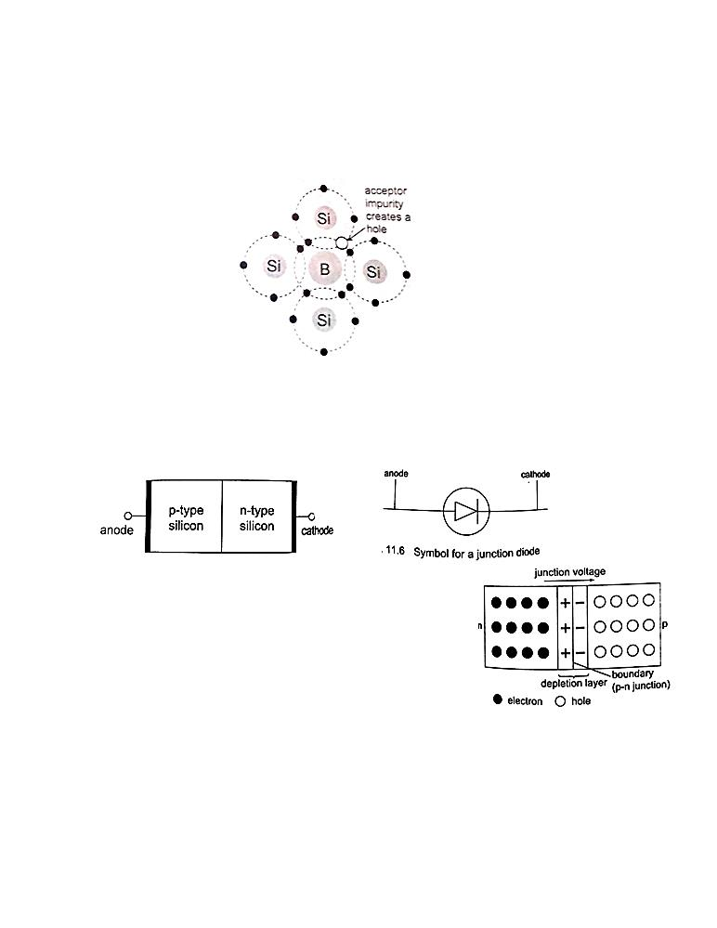
The impurity within the semi-conductor accepts atoms with free electrons (dopants). This forms a ‘hole’ within the semi-conductors.

Junction diodes
Junction refers the region where the two types of semi-conductors meet. The junctions are made by combining an n-type and p-type semi-conductor. The n-region is the cathode and the p-region is the anode.

Forward bias of a p-n junction
It occurs when the p-type block is connected to the positive terminal and the n-type block is connected to the negative terminal of a battery. The depletion layer of the junction reduces to be very thin to allow the flow of electric current.
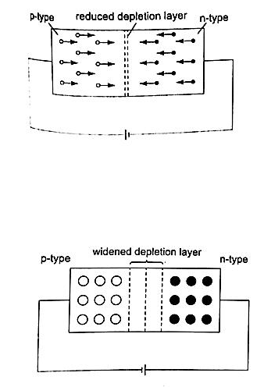

Reverse bias of a p-n junction
The negative terminal of the battery is connected to the p-type region while the n-type isconnected to positive terminal.

The depletion layer widens and resists the flow of electrons to minimal or zero (no currentflowing through) when the electric field increases beyond critical point the diode junction eventually breaks down and at this voltage it is referred to as the breakdown voltage. Diodes are intended to operate below the breakdown voltage.
Applications of junction diodes
They are mainly used for rectification of a.c. current for use by many electrical appliances. Rectification is the conversion of sinusoidal waveform into unidirectional (non -zero) waveform.
Half wave rectification
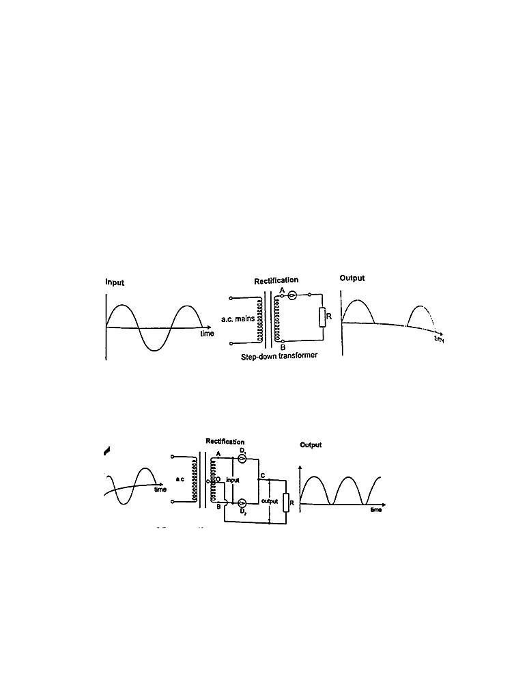
In this case the first half cycle of a sinusoidal waveform is positive and the inclusion of a reverse biased diode makes the current not to flow to the negative side of the wave. The current therefore conducts on every half cycle hence a half wave rectification is achieved. The voltage is d.c. and always positive in value though it is not steady and needs to be smoothed by placing a large capacitor in parallel to the load as shown.

Centre-tap full wave rectification
This is achieved by using a transformer whose output has a centre tap that is taken at two points where one is half the other as shown.

Bridge full wave rectification
In this case a bridge rectifier is used to achieve a full wave rectification. The current flows in the same direction in both half cycles.
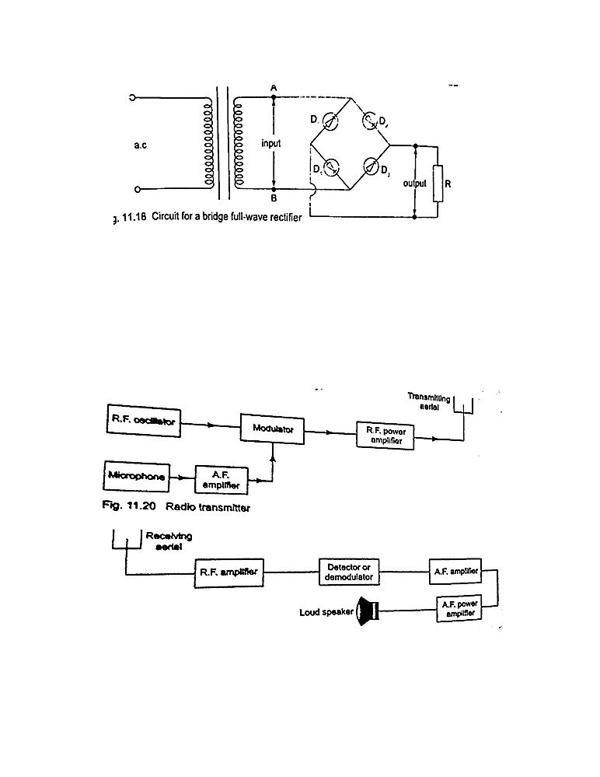

Radio transmitter and receiver
Radio waves are produced by circuits that make electrons vibrate and they are known as oscillators which produce varied frequencies. Since radio waves have greater range in air than sound or even light waves they are used as carriers of audio (sound) and visual information (TV) waves. The sound is first changed into electrical vibrations by use of a microphone or other device then added to the radio carrier wave and this changes the amplitude of the carrier and is
called amplitude modulation. The modulated wave is given out by the transmitting aerial and received by another aerial in a radio or TV when they cause vibrations between the earth and
the aerial. They are then demodulated by a diode and hence heard as a sound or image.

