CHEMISTRY PRACTICALS NOTES
Introduction/Rationale
Chemistry is a science.
Chemistry practical all over the world is emphasized to all candidates sitting for a Chemistry paper.
There are about seven main basic universal emphasis for all chemistry candidates sitting for a chemistry paper;
(i)Titration /volumetric analysis
(ii)Thermochemistry(energy changes)
(iii)Chemical kinetic(rates of reaction)
(iv)Qualitative analysis(organic/inorganic)
(v)Solubility and solubility curves
(vi)Flame test
(vii)Physical / general chemistry

Titration/volumetric analysis
Titration is determining the end point of the burette contents that react with fixed (usually 25.0cm3 from a pipette) conical flask contents.
As evidence of a titration actually done, examining body require the candidate to record their burette readings before and after the titration.
For KCSE candidates burette readings must be recorded in a titration table in the format provided by the Kenya National Examination Council.
As evidence of all titration actually done Kenya National Examination Council require the candidate to record their burette readings before and after the titration to complete the titration table in the format provided.
Sample Titration table format
Final burette reading (cm3) | 24.0 | 24.0 | 24.0
Initial burette reading (cm3 | 0.0 | 0.0 | 0.0
Volume of solution used(cm3) | 24.0 | 24.0 | 24.0

Calculate the average volume of solution used
24.0 + 24.0 + 24.0 = 24.0 cm3
3
As evidence of understanding the degree of accuracy of burettes ,all readings must be recorded to a decimal point.
As evidence of accuracy in carrying the out the titration ,candidates value should be within 0.2 of the school value .
The school value is the teachers readings presented to the examining body/council based on the concentrations of the solutions s/he presented to her/his candidates.
Bonus mark is awarded for averaged reading within 0.1 school value as Final answer.
Calculations involved after the titration require candidates thorough practice mastery on the:
(i)relationship among the mole, molar mass, mole ratios, concentration, molarity.
(ii) mathematical application of 1st principles.
Very useful information which candidates forget appear usually in the beginning of the paper as:
“You are provided with…”
All calculation must be to the 4th decimal point unless they divide fully to a lesser decimal point.
Never round off answers.

b)Thermochemistry/energy changes
Energy is the capacity to do work which is measured in Joules(J) or(kJ) .
Chemical/physical changes take place with absorption (Endothermic ) or evolution/ production (Exothermic)of heat.
Practically:
(i)endothermic changes show absorption of heat by a fall / drop in temperature and has a +∆H
(ii)exothermic changes show evolution/ production of heat by a rise in temperature and has a -∆H
(iii)temperature is measure using a thermometer.
(iv)a school thermometer is either coloured (alcohol) or colourless(mercury)
(v) For accuracy ,candidates in the same practical session should use the same type of thermometer.
(vi) fall / drop (+∆H) in temperature is movement of thermometer level downward.
(vii) rise (-∆H) in temperature is movement of thermometer level upwards.
Physical changes changes mainly involve melting/freezing/fussion and boiling /vapourization.
Chemical changes changes mainly involve displacement ,dissolving , neutralization
a).Energy changes in physical processes
Melting/freezing/fusion/solidification and boiling/vaporization/evaporation are the two physical processes.
Melting /freezing point of pure substances is fixed /constant.
The boiling point of pure substance depends on external atmospheric pressure.
Melting/fusion is the physical change of a solid to liquid. Freezing/fusion is the physical change of a liquid to solid.
Melting/freezing/fusion/solidification are therefore two opposite but same reversible physical processes. i.e
A (s) ========A(l)
Boiling/vaporization/evaporation is the physical change of a liquid to gas/vapour. Condensation/liquidification is the physical change of gas/vapour to liquid. Boiling/vaporization/evaporation and condensation/liquidification are therefore two opposite but same reversible physical processes. i.e
B (l) ========B(g)
Practically
Melting/liquidification/fusion involves heating a solid to weaken the strong bonds holding the solid particles together.
Solids are made up of very strong bonds holding the particles very close to each other (Kinetic Theory of matter
On heating these particles gain energy/heat from the surrounding heat source to form a liquid with weaker bonds holding the particles close together but with some degree of freedom.
Melting/fusion is an endothermic (+∆H)process that require/absorb energy from the surrounding.
(ii)Freezing/fusion/solidification involves cooling a a liquid to reform /rejoin the very strong bonds to hold the particles very close to each other as solid and thus lose their degree of freedom (Kinetic Theory of matter).
Freezing /fusion / solidification is an exothermic (-∆H)process that require particles holding the liquid together to lose energy to the surrounding.
(iii)Boiling/vaporization/evaporation involves heating a liquid to completely break/free the bonds holding the liquid particles together.
Gaseous particles have high degree of freedom (Kinetic Theory of matter). Boiling /vaporization / evaporation is an endothermic (+∆H) process that require/absorb energy from the surrounding.
(iv)Condensation/liquidification is reverse process of boiling /vaporization / evaporation.
It involves gaseous particles losing energy to the surrounding to form a liquid.It is an exothermic(+∆H) process.
The quantity of energy required to change one mole of a solid to liquid or to form one mole of a solid from liquid at constant temperature is called molar enthalpy/latent heat of fusion. e.g.
H₂O(s) -> H₂O(l) ∆H = +6.0kJ mole⁻¹ (endothermic process)
H₂O(l) -> H₂O(s) ∆H = -6.0kJ mole⁻¹ (exothermic process)
The quantity of energy required to change one mole of a liquid to gas/vapour or to form one mole of a liquid from gas/vapour at constant temperature is called molar enthalpy/latent heat of vapourization. e.g.
H₂O(l) -> H₂O(g) ∆H = +44.0kJ mole⁻¹ (endothermic process)
H₂O(g) -> H₂O(l) ∆H = -44.0kJ mole⁻¹ (exothermic process)
To determine the boiling point of water
Procedure:
Measure 20cm3 of tap water into a 50cm3 glass beaker. Determine and record its temperature.Heat the water on a strong Bunsen burner flame and record its temperature after every thirty seconds for four minute
Sample results
Time  (seconds) | 0 | 30 | 60 | 90 | 120 | 150 | 180 | 210 | 240
Temperature(ºC) | 25.0 | 45.0 | 85.0 | 95.0 | 96.0 | 96.0 | 96.0 | 97.0 | 98.0
Questions
1.Plot a graph of temperature against time(y-axis)
Sketch graph of temperature against time

2.From the graph show and determine the boiling point of water
Note:
Water boils at 100ºC at sea level/one atmosphere pressure/101300Pa but boils at below 100ºC at higher altitudes.
The sample results above are from Kiriari Girls High School-Embu County on the slopes of Mt Kenya in Kenya. Water here boils at 96ºC.
3.Calculate the molar heat of vaporization of water.(H= 1.0,O= 16.O)
Working:
Mass of water = density x volume => (20 x 1) /1000 = 0.02kg
Quantity of heat produced
= mass of water x specific heat capacity of water x temperature change
=>0.02kg x 4.2 x ( 96 – 25 ) = -5.964kJ

Heat of vaporization of one mole H₂O
= Quantity of heat
Molar mass of H₂O

=> -5.964kJ = -0.3313 kJ mole ⁻¹
18
To determine the melting point of candle wax
Procedure
Weigh exactly 5.0 g of candle wax into a boiling tube. Heat it on a strongly Bunsen burner flame until it completely melts.
Insert a thermometer and remove the boiling tube from the flame. Stir continuously. Determine and record the temperature after every 30seconds for four minutes.
Sample results
Time  (seconds) | 0 | 30 | 60 | 90 | 120 | 150 | 180 | 210 | 240 | 240
Temperature  (ºC) | 93.0 | 85.0 | 78.0 | 70.0 | 69.0 | 69.0 | 69.0 | 67.0 | 65.0 | 65.0

Questions
1.Plot a graph of temperature against time(y-axis)
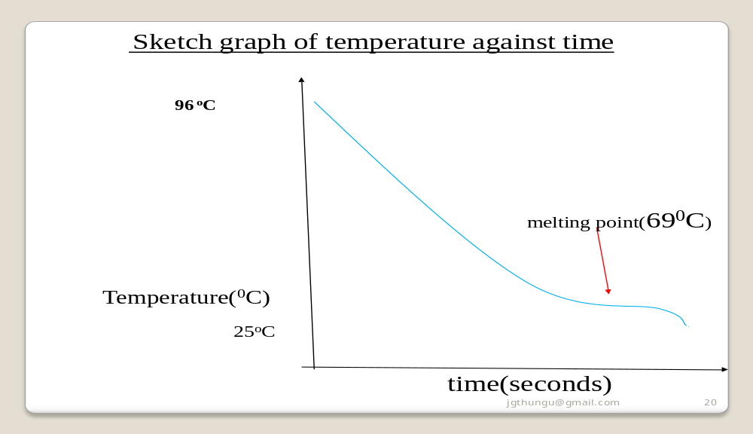
b)Energy changes in chemical processes
(i)Standard enthalpy/heat of displacement ∆Hᶿ_{d}
(ii)Standard enthalpy/heat of neutralization ∆Hᶿ_{n}
(iii)Standard enthalpy/heat of solution/dissolution ∆Hᶿ_{s}
Standard enthalpy/heat of displacement ∆Hᶿ_{d}
The molar standard enthalpy/heat of displacement may be defined as the energy/heat change when one mole of substance is displaced /removed from its solution at standard conditions
Some displacement reactions
(i)Zn(s) + CuSO₄(aq) -> Cu(s) + ZnSO₄(aq)
Ionically: Zn(s) + Cu²⁺(aq) -> Cu(s) + Zn²⁺ (aq)
(ii)Fe(s) + CuSO₄(aq) -> Cu(s) + FeSO₄(aq)
Ionically: Fe(s) + Cu²⁺(aq) -> Cu(s) + Fe²⁺ (aq)
(iii)Pb(s) + CuSO₄(aq) -> Cu(s) + PbSO₄(s)
This reaction stops after some time as insoluble PbSO₄(s) coat/cover unreacted lead.
(iv)Cl₂(g) + 2NaBr(aq) -> Br₂(aq) + 2NaCl(aq)
Ionically:
Cl₂(g)+ 2Br⁻ (aq) -> Br₂(aq) + 2Cl⁻ (aq)
To determine the molar standard enthalpy/heat of displacement(∆Hᶿ_{d}) of copper
Procedure
Place 20cm3 of 0.2M copper(II)sulphate(VI)solution into a 50cm3 plastic beaker/calorimeter.
Determine and record the temperature of the solution T₁.
Put all the Zinc powder provided into the plastic beaker. Stir the mixture using the thermometer.
Determine and record the highest temperature change to the nearest 0.5ºC- T₂ .
Repeat the experiment to complete table 1 below
Sample results Table 1
Experiment | I | II
Final temperature of solution(T₂) | 30.0ºC | 31.0ºC
initial temperature of solution(T₁) | 25.0ºC | 24.0ºC
Change in temperature(∆T) | 5.0 | 6.0
Questions
1.(a) Calculate:
(i)average ∆T
Average ∆T = change in temperature in experiment I and II
=>5.0 + 6.0 = 5.5ºC
2
(ii)the number of moles of solution used
Moles used = molarity x volume of solution = 0.2 x 20 = 0.004 moles
1000 1000
(iii) the enthalpy change ∆H for the reaction
Heat produced ∆H = mass of solution(m) x specific heat capacity (c)x ∆T
=> 20 x 4.2 x 5.5 = 462 Joules = -0.462 kJ
1000 1000
(iv)State two assumptions made in the above calculations.
Density of solution = density of water = 1gcm⁻³
Specific heat capacity of solution=Specific heat capacity of water =4.2 kJ⁻¹kg⁻¹K
This is because the solution is assumed to be infinite dilute.
2. Calculate the enthalpy change for one mole of displacement of Cu²⁺ (aq) ions.
Molar heat of displacement ∆H_{d} = Heat produced ∆H
Number of moles of fuel
=> 0.462 kJ = -115.5 kJmole⁻¹
0.004
3.Write an ionic equation for the reaction taking place.
Zn(s) + Cu²⁺(aq) -> Cu(s) + Zn²⁺(aq)
4.State the observation made during the reaction.
Blue colour of copper(II)sulphate(VI) fades/becomes less blue/colourless.
Brown solid deposits are formed at the bottom of reaction vessel/ beaker.
5.Illustrate the above reaction using an energy level diagram.
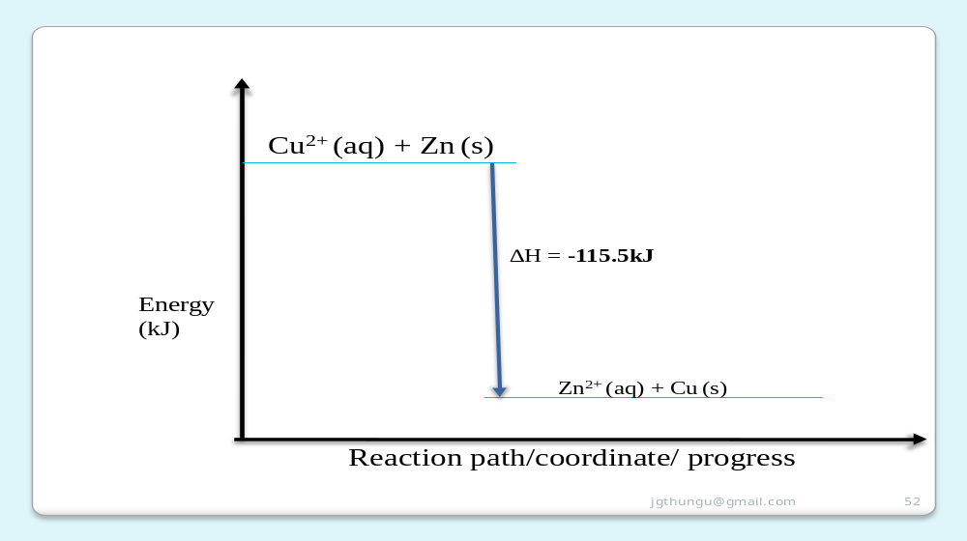
8. The enthalpy of displacement ∆H_{d} of copper(II)sulphate (VI) solution is 12k6kJmole⁻¹.Calculate the molarity of the solution given that 40cm3 of this solution produces 2.204kJ of energy during a displacement reaction with excess iron filings.
Number of moles = Heat produced ∆H
Molar heat of displacement ∆H_{d}

=> 2.204 kJ = 0.0206moles
126 moles
Molarity of the solution = moles x 1000
Volume of solution used

= 0.0206moles x 1000 = 0.5167 M
40
Graphical determination of the molar enthalpy of displacement of copper
Procedure:
Place 20cm3 of 0.2M copper(II)sulphate (VI) solution into a calorimeter/50cm3 of plastic beaker wrapped in cotton wool/tissue paper.
Record its temperature at time T= 0.Stir the solution with the thermometer carefully and continue recording the temperature after every 30 seconds .
Place all the (1.5g) Zinc powder provided after 1 ½ minutes.
Stir the solution with the thermometer carefully and continue recording the temperature after every 30 seconds for five minutes.
Determine the highest temperature change to the nearest 0.5ºC.
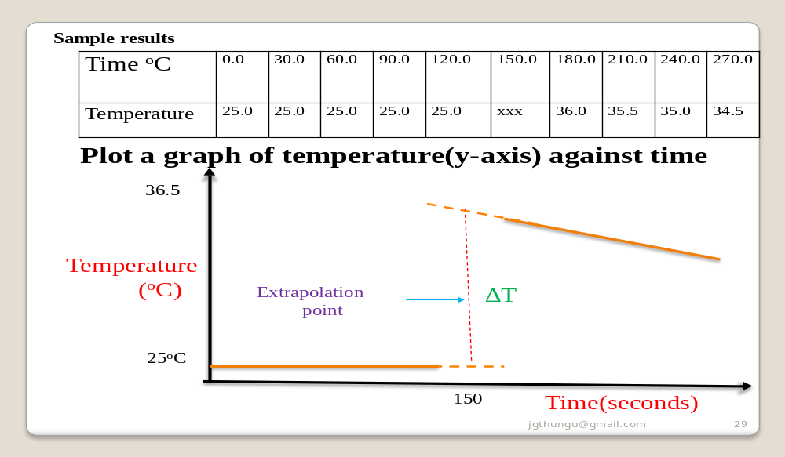Questions
1.Show and determine the change in temperature ∆T
From a well constructed graph ∆T= T2 –T1 at 150 second by extrapolation
∆T = 36.5 – 25.0 = 11.5ºC
2.Calculate the number of moles of copper(II) sulphate(VI)used given the molar heat of displacement of Cu²⁺ (aq)ions is 125kJmole⁻¹
Heat produced ∆H = mass of solution(m) x specific heat capacity (c)x ∆T
=> 20 x 4.2 x 11.5 = 966 Joules = -0.966 kJ
1000
Number of moles = Heat produced ∆H Molar heat of displacement ∆H_{d}
=> 0.966 kJ = -0.007728moles
125 moles -7.728 x 10⁻³moles
3. What was the concentration of copper(II)sulphate(VI) in moles per litre.
Molarity = moles x 1000
Volume used
=>7.728 x 10⁻³moles x 1000 = 0.3864M
20
4.The actual concentration of copper
(II) Sulphate (VI) solution was 0.4M. Explain the differences between the two.
Practical value is lower than theoretical
. Heat/energy loss to the surrounding and that absorbed by the reaction vessel decreases ∆T hence lowering the practical number of moles and molarity against the theoretical value
(c)Standard enthalpy/heat of neutralization ∆Hᶿ_{n}
The molar standard enthalpy/heat of neutralization ∆Hᶿ_{n} is defined as the energy/heat change when one mole of a H⁺ (H₃O⁺)ions react completely with one mole of OH⁻ ions to form one mole of H₂O/water.
Neutralization is thus a reaction of an acid /H⁺ (H₃O⁺)ions with a base/alkali/ OH⁻ ions to form salt and water only.
Strong acids/bases/alkalis are completely/fully/wholly dissociated to many free ions(H⁺ /H₃O⁺ and OH⁻ ions).
(ii) for strong acid/base/alkali neutralization, no energy is used to dissociate /ionize since molecule is wholly/fully dissociated/ionized into free H⁺ H₃O⁺ and OH⁻ ions.
The overall energy evolved is comparatively higher / more than weak acid-base/ alkali neutralizations.
For strong acid-base/alkali neutralization, the enthalpy of neutralization is constant at about 57.3kJmole⁻¹ irrespective of the acid-base used.
This is because ionically:
OH⁻(aq)+ H⁺(aq) -> H₂O(l)
for all wholly/fully /completely dissociated acid/base/alkali
Weak acids/bases/alkalis are partially dissociated to few free ions(H⁺ (H₃O⁺ and OH⁻ ions) and exist more as molecules.
Neutralization is an exothermic(-∆H) process.
The energy produced during neutralization depend on the amount of free ions (H⁺ H₃O⁺ and OH⁻)ions existing in the acid/base/alkali reactant:
(i)for weak acid-base/alkali neutralization,some of the energy is used to dissociate /ionize the molecule into free H⁺ H₃O⁺ and OH⁻ ions therefore the overall energy evolved is comparatively lower/lesser/smaller than strong acid / base/ alkali neutralizations.
Practically ∆Hᶿ_{n} can be determined as in the examples below:
To determine the molar enthalpy of neutralization ∆H_{n} of Hydrochloric acid
Procedure
Place 50cm3 of 2M hydrochloric acid into a calorimeter/200cm3 plastic beaker wrapped in cotton wool/tissue paper.
Record its temperature T₁.
Using a clean measuring cylinder, measure another 50cm3 of 2M sodium hydroxide.
Rinse the bulb of the thermometer in distilled water.
Determine the temperature of the sodium hydroxide T₂.
Average T₂ andT₁ to get the initial temperature of the mixture T₃.
Carefully add all the alkali into the calorimeter/200cm3 plastic beaker wrapped in cotton wool/tissue paper containing the acid.
Stir vigorously the mixture with the thermometer.
Determine the highest temperature change to the nearest 0.5ºC T₄ as the final temperature of the mixture.
Repeat the experiment to complete table 1.
(ii)enthalpy change ∆H of neutralization.
∆H = (m)mass of solution(acid+base) x (c)specific heat capacity of solution x ∆T(T₆) => (50 +50) x 4.2 x 13.5 = 5670Joules = 5.67kJ
(iii) the molar heat of neutralization the acid.
∆H_{n} = Enthalpy change ∆H => 5.67kJ = 56.7kJ mole⁻¹
Number of moles 0.1moles
(c)Write the ionic equation for the reaction that takes place
OH⁻(aq)+ H⁺(aq) -> H₂O(l)
(d)The theoretical enthalpy change is 57.4kJ. Explain the difference with the results above.
The theoretical value is higher
Heat/energy loss to the surrounding/environment lowers ∆T/T₆ and thus ∆H_{n}
Heat/energy is absorbed by the reaction vessel/calorimeter/plastic cup lowers ∆T and hence ∆H_{n}
Sample results
Experiment | I | II
Temperature of acid T₁ (ºC) | 22.5 | 22.5
Temperature of base T₂ (ºC) | 22.0 | 23.0
Final temperature of solution T₄(ºC) | 35.5 | 36.0
Initial temperature of solution T₃(ºC) | 22.25 | 22.75
Temperature change( T₅) | 13.25 | 13.75
(a)Calculate T₆ the average temperature change T₆ = 13.25 +13.75 = 13.5 ºC 2
(b)Why should the apparatus be very clean?
Impurities present in the apparatus reacts with acid /base lowering the overall temperature change and hence ∆Hᶿ_{n}.
(c)Calculate the:
(i)number of moles of the acid used
number of moles = molarity x volume => 2 x 50 = 0.1moles 1000 1000
(e)Compare the ∆H_{n} of the experiment above with similar experiment repeated with neutralization of a solution of:
(i) potassium hydroxide with nitric(V) acid
The results would be the same/similar.
Both are neutralization reactions of strong acids and bases/alkalis that are fully /wholly dissociated into many free H⁺ / H₃O⁺ and OH⁻ ions.
(ii) ammonia with ethanoic acid
The results would be lower/∆H_{n} would be less.
Both are neutralization reactions of weak acids and bases/alkalis that are partially /partly dissociated into few free H⁺ / H₃O⁺ and OH⁻ ions. Some energy is used to ionize the molecule.
(f)Draw an energy level diagram to illustrate the energy changes
Theoretical examples
1.The molar enthalpy of neutralization was experimentary shown to be 51.5kJ per mole of 0.5M hydrochloric acid and 0.5M sodium hydroxide. If the volume of sodium hydroxide was 20cm3, what was the volume of hydrochloric acid used if the reaction produced a 5.0ºC rise in temperature?
Working:
Moles of sodium hydroxide = molarity x volume
1000
=> 0.5 M x 20cm3 = 0.01 moles
1000
Enthalpy change ∆H = ∆H_{n} => 51.5 = 0.515kJ
Moles sodium hydroxide 0.01 moles
Mass of base + acid = Enthalpy change ∆H in Joules
Specific heat capacity x ∆T
=> 0.515kJ x 1000 = 24.5238g
4.2 x 5
Mass/volume of HCl = Total volume – volume of NaOH
=>24.5238 - 20.0 = 4.5238 cm3
Graphically ∆H_{n} can be determined as in the example below:
Procedure
Place 8 test tubes in a test tube rack .
Put 5cm3 of 2M sodium hydroxide solution into each test tube. Measure 25cm3 of 1M hydrochloric acid into 100cm3 plastic beaker.
Record its initial temperature at volume of base =0.
Put one portion of the base into the beaker containing the acid.
Stir carefully with the thermometer and record the highest temperature change to the nearest 0.5ºC.
Repeat the procedure above with other portions of the base to complete table 1 below
Volume of acid(cm3) | 25.0 | 25.0 | 25.0 | 25.0 | 25.0 | 25.0 | 25.0 | 25.0 | 25.0 | 25.0 | 25.0
Volume of alkali(cm3) | 0 | 5.0 | 10.0 | 15.0 | 20.0 | 25.0 | 30.0 | 35.0 | 40.0 | 35.0 | 40.0
Final temperature(ºC) | 22.0 | 24.0 | 26.0 | 28.0 | 28.0 | 27.0 | 26.0 | 25.0 | 24.0 | 25.0 | 24.0
Initial temperature(ºC) | 22.0 | 22.0 | 22.0 | 22.0 | 22.0 | 22.0 | 22.0 | 22.0 | 22.0 | 22.0 | 22.0
Change in temperature | 0.0 | 2.0 | 4.0 | 6.0 | 6.0 | 5.0 | 4.0 | 3.0 | 2.0 | 3.0 | 2.0
Complete the table to determine the change in temperature.
Plot a graph of volume of sodium hydroxide against temperature change.
From the graph show and determine :
(i)the highest temperature change ∆T
∆T =T₂-T₁ : highest temperature-T₂ (from extrapolating a correctly plotted graph) less lowest temperature at volume of base=0-T₁
=> 28.7 – 22.0 = 6.7 0 ºC
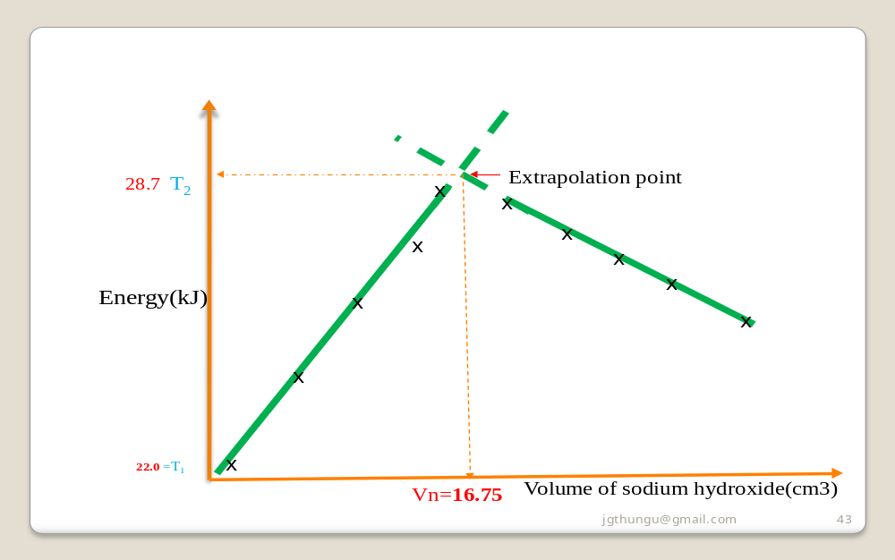
(ii) the volume of sodium hydroxide used for complete neutralization
From correctly plotted graph = 16.75 cm3
(iii) Calculate the number of moles of the alkali used
Moles NaOH = molarity x volume ()Vn=
1000
=> 2 x 16.75 = 0.0335 moles
1000
(iv)Calculate ∆H for the reaction.
∆H = mass of solution mixture x c x ∆T
=> (25.0 + 16.75) x 4.2 x 6.7
= 1174.845 J = 1.174845 kJ
1000
(iii) Calculate the molar enthalpy of the alkali:
∆Hn = Heat change => 1.174845 kJ
number of moles 0.0335 moles
= 35.0699kJ mole⁻¹
(i) Standard enthalpy/heat of solution/dissolution ∆Hᶿ_{s}
The standard enthalpy of solution ∆Hᶿ_{s} is defined as the energy change when one mole of a substance is dissolved in excess distilled water to form an infinite dilute solution.
An infinite dilute solution is one which is too dilute to be diluted further.
Practically the heat of solution is determined by dissolving a known mass /volume of a solute in known mass/volume of water/solvent and determining the temperature change.
To determine the heat of dissolution of ammonium nitrate(V)
Place 100cm3 of distilled water into a plastic cup/beaker/calorimeter
Put all the 5.0g of ammonium nitrate(v)/potassium nitrate(V)/ ammonium chloride into the water.
Stir the mixture using the thermometer and record the temperature change after every ½ minute to complete table1.
Continue stirring throughout the experiment.

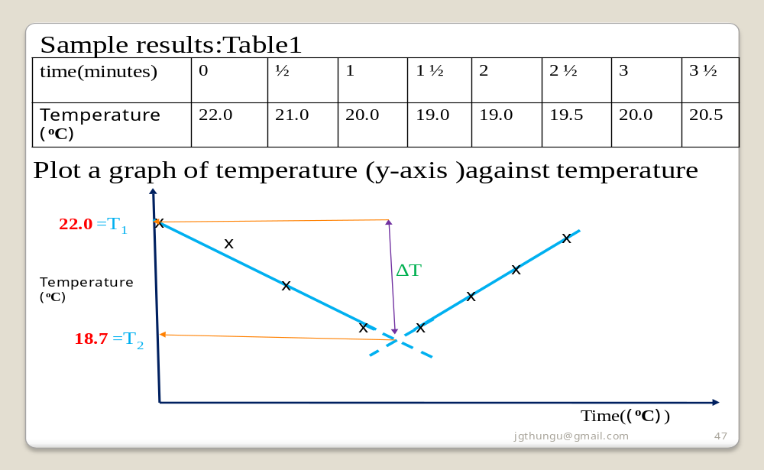
(a)From the graph show and determine:
(i)the highest temperature change ∆T
∆T =T₂-T₁ : highest temperature-T₂ (from extrapolating a correctly plotted graph) less lowest temperature at volume of base=0-T₁
=> 18.7 – 22.0 = 3.3 ºC ( not -3.3 ºC)
(b) Calculate the total energy change ∆H during the reaction
∆H = mass of water x c x ∆T
=>∆H=100 x4.2 x 3.3 ºC = + 1386 J = + 1.386 kJ
1000
(c) Calculate the number of moles of ammonium nitrate (v) used
Moles = mass => 5.0 = 0.0625 moles
molar mass 80
(d)What is the molar heat of dissolution of ammonium nitrate(V)
∆H = Heat change = + 1.386 kJ = + 22.176 kJmole⁻¹
Number of mole 0.0625 moles
(e)What would happen if the distilled water is heated before experiment was performed .
The ammonium nitrate(V) would take less time to dissolve.
Increase in temperature reduces lattice energy causing endothermic dissollution to be faster.
(e)Illustrate the above process on an energy level diagram

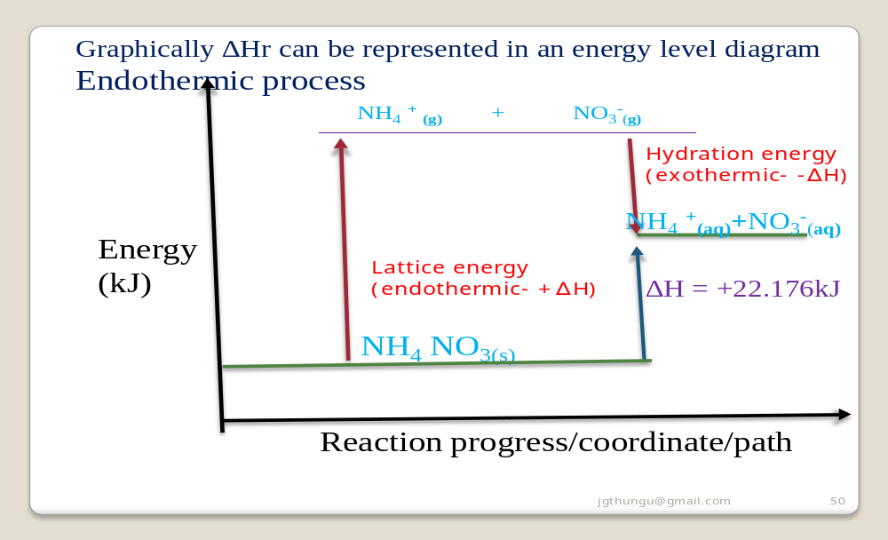

c)Chemical Kinetic/Rate of reaction
The rate of a chemical reaction can be defined as the time taken for a known amount of reactants to form known amount of products.
Some reactions are too slow to be determined e.g weathering others are instantaneous
The SI unit of time is seconds. Minutes and hours are also common .
Time is determined using a stop watch/clock
Candidates using stop watch/clock should learn to:
(i)Press start button concurrently with starting off determination of a reaction using one hand each.
(ii)Press stop button when the reaction is over.
(iii)Record all times in seconds unless specified.
(iv)Press reset button to begin another timing
(v)Ignore time beyond seconds for stop clock/watch beyond this accuracy
(vi)Avoid accidental pressing of any button before recording
It can be very frustrating repeating a whole procedure
The following factors theoretically and practically alter/influence/affect/determine the rate of a chemical reaction:
(a)Concentration
(b)Temperature
(a)Concentration
An increase in concentration increases the rate the rate of reaction by reducing the time taken to completion.
Theoretically, increase in concentration is a decrease in distance between reacting particles which increases their collision frequency.
Practically decreasing concentration is diluting/adding water
To demonstrate the effect of concentration on reaction rate
You are provided with
(i) sodium thiosulphate containing 40gdm ⁻3 solution labeled A
(ii) 2M hydrochloric acid labeled solution B
You are required to determine the rate of reaction between solution A and B
Procedure
Measure 40cm3 of solution A into 100 cm3 glass beaker. Place it on top of a pen-mark “X”. Measure another 40cm3 of solution B. Simultaneously put solution B into solution A and start off a stop watch/clock. Determine the time taken for the pen-mark “X” to be invisible/obscurred from above. Repeat the procedure by measuring 35cm3 of solution B and adding 5cm3 of water. Complete the table 1 below by using other values os solution B and water
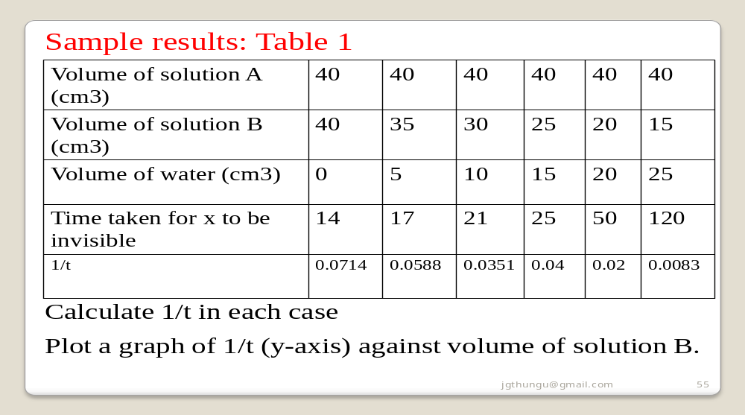

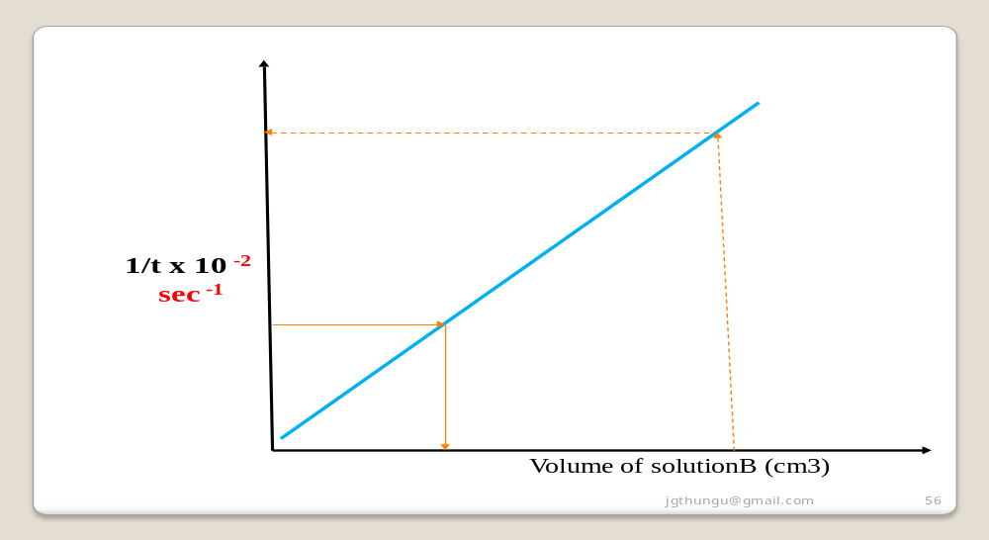
Sample questions
(i)Explain the shape of the graph
(Straight line graph from the origin)
Decrease in concentration decreases the rate of reaction. The higher the concentration of solution B the less time taken for mark x to be obscurred/invisible due to increased collision frequency between the reacting particles.
(ii)From the graph determine the time taken for the mark to be invisible at 37cm3
At 37cm3 then 1/t => 1/ 37 = 0.027
From a well plotted graph:
1/t = 0.027 => 16.2602 seconds
(ii)From the graph determine the volume of solution B at 100 seconds
100 seconds => 1/t = 1 / 1000 = 0.01
From a well plotted graph:
At 1/t = 0.01 => the volume of B = 17.0cm3
(iii) State another factor that would alter the rate of the above reaction.
Temperature
(iii) State another factor that would not alter the rate of the above reaction.
Surface area
Pressure
Catalyst
(b) Temperature
An increase in temperature increases the rate of reaction.
An increase of 10 ºC/10K practically doubles the rate of a chemical reaction/reduces time of completion by ¹/₂.
An increase in temperature increase the kinetic energy of reacting particles increasing their collision frequency
Practically ,increase in temperature involves heating the reactants
The results and presentation should be as in the effect of concentration.
Increased temperature reverses the table I time results
i.e less time as temperature increases.

d)Qualitative analysis
Process of identifying unknown compounds
Compounds may be:
(i)Inorganic
(ii)organic

Inorganic analysis:
This involve mainly identification of ionic compounds containing cations and anions.
Cations present in an ionic compounds are identified by adding a precipitating reagent that forms a precipitate unique to the cation/s in the compound.
The main precipitating reagents used are:
2M NaOH and/or 2M NH₃(aq)
When using 2M sodium hydroxide:
(i)No white precipitate is formed if K ⁺ and Na ⁺ ions are present
(ii) No white precipitate is formed if NH₄⁺ ions are present but a clourless gas with pungent smell of urine is produced which may not be recognized in a school laboratory examination setting.
(iii)White precipitate that dissolves / soluble in excess if Zn²⁺ Pb²⁺ Al³⁺ ions are present.
(iv)White precipitate that do not dissolves/insoluble in excess if Ba²⁺ Mg²⁺ Ca²⁺ ions are present.
(v)Blue precipitate that do not dissolves /insoluble in excess if Cu²⁺ ions are present.
(vi)Green precipitate that do not dissolves/insoluble in excess if Fe²⁺ ions are present.
(vii)Brown precipitate that do not dissolves/insoluble in excess if Fe³⁺ ions are present.
When using 2M aqueous ammonia
(i)No white precipitate is formed if K ⁺ ,NH₄⁺ Na ⁺ ions are present
(ii)White precipitate that dissolves / soluble in excess if Zn²⁺ ions are present.
(iii)White precipitate that do not dissolves/insoluble in excess if Ba²⁺ Mg²⁺ Ca²⁺ Pb²⁺ Al³⁺ ions are present.
(iv)Blue precipitate that dissolves /soluble in excess to form a deep/royal blue solution in excess if Cu²⁺ ions are present.
(v)Green precipitate that do not dissolves/insoluble in excess if Fe²⁺ ions are present.
(vi)Brown precipitate that do not dissolves/insoluble in excess if Fe³⁺ ions are present.
Anions present in an ionic compounds are identified by adding a specific precipitating reagent that forms a precipitate unique to the specific anion/s in the compound.
(i)Lead(II)nitrate(V) solution
Lead forms insoluble PbSO_{4 ,}PbSO_{3 ,}PbCO_{3,} PbS, PbI_{2,}PbCl₂
PbS is a black precipitate,
PbI₂ is a yellow precipitate.
All the others are white precipitates.
(a)If a Lead(II)nitrate(V) solution is added to a substance/ solution/ compound :
(i)A yellow ppt shows presence of I⁻ ions
(ii)A black ppt shows presence of S²⁻ ions
(iii) A white ppt shows presence of SO₄²⁻ ,SO₃²⁻ ,CO₃²⁻ Cl⁻
(b)If the white precipitate is added dilute nitric(V) acid:
(i)It dissolves to show presence of SO₃²⁻ ,CO₃²⁻
(ii)It persist/remains to show presence of SO₄²⁻, Cl⁻
(c)If the white precipitate in b(i) is added acidified potassium manganate(VII)/ dichromate(VI)
(i) acidified potassium manganate(VII) is decolorized /orange colour of acidified potassium dichromate(VI) turns to green to show presence of SO₃²⁻
(ii) acidified potassium manganate(VII) is not decolorized /orange colour of acidified potassium dichromate(VI) does not turn to green/remains orange to show absence of SO₃²⁻ /presence of CO₃²⁻
(c)If the white precipitate in b(ii) is boiled:
(i)It dissolves to show presence of Cl⁻
(ii)It persist/remains to show presence of SO₄²⁻
(ii)Barium(II)nitrate(V)/Barium chloride solution
Barium(II)nitrate(V)/Barium chloride solution precipitates BaSO_{4 ,}BaSO_{3 ,} BaCO_{3,} from SO₄²⁻ ,SO₃²⁻ ,CO₃²⁻ ions.
Inorganic qualitative analysis require continous practice discussion
Sample presentation of results
You are provided with solid Y(aluminium (III)sulphate(VI)hexahydrate).Carry out the following tests and record your observations and inferences in the space provided.
1(a) Appearance
Observations inference (1mark)

White crystalline solid Coloured ions Cu²⁺ , Fe²⁺ ,Fe³⁺ absent

(b)Place about a half spatula full of the solid into a clean dry boiling tube. Heat gently then strongly.
Observations inference (1mark)

Colourless droplets formed on the cooler Hydrated compound/compound
part of the test tube containing water of crystallization
Solid remains a white residue

(c)Place all the remaining portion of the solid in a test tube .Add about 10cm3 of distilled water. Shake thoroughly. Divide the mixture into five portions.
Observation Inference (1mark)
Solid dissolves to form Polar soluble compound
a colourless solution Cu²⁺ , Fe²⁺ ,Fe³⁺ absent
(i)To the first portion, add three drops of sodium hydroxide then add excess of the alkali.
Observation Inference (1mark)
White ppt, soluble in excess Zn²⁺ , Pb²⁺ , Al³⁺
(ii)To the second portion, add three drops of aqueous ammonia then add excess of the alkali.
Observation Inference (1mark)
White ppt, insoluble in excess Pb²⁺ , Al³⁺
(iii)To the third portion, add three drops of sodium sulphate(VI)solution.
Observation Inference (1mark)
No white ppt Al³⁺
(iv)I.To the fourth portion, add three drops of Lead(II)nitrate(IV)solution. Preserve
Observation Inference (1mark)
White ppt CO₃²⁻, SO₄²⁻, SO₃²⁻, Cl⁻,
II.To the portion in (iv) I above , add five drops of dilute hydrochloric acid.
Observation Inference (1mark)
White ppt persist/remains SO₄²⁻, Cl⁻,
III.To the portion in (iv) II above, heat to boil.
Observation Inference (1mark)
White ppt persist/remains SO₄²⁻,

Organic analysis:
This involve mainly identification of the functional group:
(i) - C = C- / = C = C= / C - C

R OH

(iii) R COOH / H⁺

These functional groups can be identified by:
(i)burning-a substance which “catches fire” must reduce in amount.
Candidates should not confuse burning with flame coloration/test
(ii)Decolorization of bromine water/chlorine water/acidified KMnO ₄ / to show presence of

C = C - / - C = C - and R – OH

(iii)Turning orange acidified K ₂ Cr ₂ O ₇ to green to show presence as in above.
(iii)pH 1/2/3 for strongly acidic solutions. pH 4/5/6 for weakly acidic solutions
(iv)Turning blue litmus paper red. red litmus paper remaining red show presence of H⁺ ions
d)Flame test
The colour change on a clear colourless Bunsen flame is useful in identifying some cations / metals.
A very clean metallic spatula is recommended since dirt obscures /changes the correct coloration distinct flame coloration of some compounds
Barium/barium salts | orange
Sodium/ sodium salts | yellow
Potassium/potassium salts | Purple/lilac
Lithium/Lithium salts | Deep red/crimson
Calcium/ calcium salts | red
Copper/copper salts | Blue/ green
(e)Physical chemistry
Chemistry is a science subject that incorporate many scientific techniques.
Examining body/council, require tabulated results/data from the candidate.
This tabulated results is usually then put in a graph.
The general philosophy of methods of presentation of chemistry practical data is therefore availability of evidence showing:
(i)Practical done(complete table)
(ii)Accuracy of apparatus used(decimal point)
(iii)Accuracy/care in doing experiment to get collect trend(against teachers results)
(iv)Graphical work(use of mathematical science)
(v)Calculations (Scientific mathematical integration)

(f)Sample practicals
Name ………………..………………….Class…………..Index No……………..
Candidate’s signature………………………………..
Date done………………Date marked………… .……Date revised…………….…..….
233/3
CHEMISTRY Paper 3
PRACTICAL.
Pre-KCSE Practice 1: 2013
MARKS SCHEME

Instruction to Candidate
Write your name and index number in the spaces provided above.
Sign and write the date of examination in the spaces provided above
Answer all questions in the spaces provided.
Mathematical tables and electronic calculators may be used.
All working must be clearly shown where necessary.
This paper consist of 8 printed pages.
Candidates should check the question paper to ascertain that all the pages are printed and indicated and that no questions are missin
For examiners use only
Question | Maximum score | Candidates core
1 | 20 | 20
2 | 10 | 10
3 | 10 | 10
Total score | 40 | 40
1.You are provided with:
(i)solution L containing 5.0g per litre of a dibasic organic acid H₂X.2H₂O.
(ii)solution M which is acidified potassium manganate(VII)
(iii)solution N a mixture of sodium ethanedioate and ethanedioic acid
(iv)0.1M sodium hydroxide solution P
(v)1.0M sulphuric(VI)
You are required to:
(i)standardize solution M using solution L
(ii)use standardized solution M and solution P to determine the % of sodium ethanedioate in the mixture.
Procedure 1
Fill the burette with solution M. Pipette 25.0cm3 of solution L into a conical flask. Heat this solution to about 70ºC(but not to boil).Titrate the hot solution L with solution M until a permanent pink colour just appears .Shake thoroughly during the titration. Repeat this procedure to complete table 1.
Table 1
 | 1 | 2 | 3
Final burette reading (cm3) | 20.0 | 20.0 | 20.0
Initial burette reading (cm3) | 0.0 | 0.0 | 0.0
Volume of N used (cm3) | 20.0 | 20.0 | 20.0
(2marks)
(a)Calculate the average volume of solution L used (1mk)
20.0 + 20.0+ 20.0 = 20.0cm3
3
(b)Given that the concentration of the dibasic acid is 0.05molesdm⁻³.determine the value of x in the formula H₂X.2H₂O (H=1.0,O=16.0) (1mark)
Molar mass H₂X.2H₂O = mass / litre =>
moles / litre
5.0g/litre = 100 g
0.05molesdm⁻³
H₂X.2H₂O =100
X = 100 – ((2 x1) + 2 x (2 x1) + (2 x 16) => 100 – 34 = 62
(c) Calculate the number of moles of the dibasic acid H₂X.2H₂O. (1mark)
Moles = molarity x pipette volume =>
1000
0.05 x 25 = 0.00125 / 1.25 x10 ⁻³ moles
1000
(d)Given the mole ratio manganate(VII)(MnO₄⁻): acid H₂X is 2:5, calculate the number of moles of manganate(VII) (MnO₄⁻) in the average titre. (1mark)
Moles H₂X = ²/₅ moles of MnO₄⁻
=> ²/₅ x 0.0125/1.25 x10 ⁻² moles = 0.0005 / 5.0 x 10 ⁻⁴ moles
(e)Calculate the concentration of the manganate(VII)(MnO₄⁻) in moles per litre.
(1mark)
Moles per litre/molarity = moles x 1000
average burette volume
=> 0.0005/5.0 x 10 ⁻⁴moles x 1000 = 0.02083 moles l⁻¹ / M
24.0
Procedure 2
With solution M still in the burette ,pipette 25.0cm3 of solution N into a conical flask. Heat the conical flask containing solution N to about 70ºC.Titrate while hot with solution M. Repeat the experiment to complete table 2.
Table 2 (2marks)
 | 1 | 2 | 3
Final burette reading (cm3) | 12.5 | 12.5 | 12.5
Initial burette reading (cm3) | 0.0 | 0.0 | 0.0
Volume of N used (cm3) | 12.5 | 12.5 | 12.5

(a)Calculate the average volume of solution L used (1mk)
12.5 + 12.5 + 12.5 = 12.5 cm3
3
(b)Calculations:
(i)How many moles of manganate(VII)ions are contained in the average volume of solution M used? (1mark)
Moles = molarity of solution M x average burette volume
1000
=> 0.02083 molesl⁻¹/ M x 12.5 = 0.00026 / 2.6 x 10⁻⁴ moles
1000
(ii)The reaction between manganate(VII)ions and ethanedioate ions that reacted with is as in the equation:
2MnO₄⁻ (aq) + 5C₂O₄²⁻ (aq) + 16H⁺ (aq) -> 2Mn²⁺(aq) + 10CO₂(g) + 8H₂O(l)
Calculate the number of moles of ethanedioate ions that reacted with manganate (VII) ions in the average volume of solution M. (1mark)
From the stoichiometric/ionic equation:
mole ratio MnO₄⁻ (aq): C₂O₄²⁻ (aq) = 2:5
=> moles C₂O₄²⁻ = ⁵/₂ moles MnO₄⁻
=> ⁵/₂ x 0.00026 / 2.5 x 10⁻³ moles
= 0.00065 / 6.5 x10⁻⁴ moles
(iii)Calculate the number of moles of ethanedioate ions contained in 250cm3 solution N. (1mark)
25cm3 pipette volume -> 0.00065 /6.5 x10⁻⁴ moles
250cm3 -> 0.0065 /6.5 x10⁻³ moles x 250 = 0.0065 / 6.5 x10⁻³ moles
25
Procedure 3
Remove solution M from the burette and rinse it with distilled water. Fill the burette with sodium hydroxide solution P. Pipette 25cm3 of solution N into a conical flask and add 2-3 drops of phenolphthalein indicator. Titrate this solution N with solution P from the burette. Repeat the procedure to complete table 3.
Table 3
 | 1 | 2 | 3
Final burette reading (cm3) | 12.5 | 12.5 | 12.5
Initial burette reading (cm3) | 0.0 | 0.0 | 0.0
Volume of N used (cm3) | 12.5 | 12.5 | 12.5
(2 mark)
(a)Calculate the average volume of solution L used (1mk)
12.5 + 12.5 + 12.5 = 12.5 cm3
3
(b)Calculations:
(i)How many moles of sodium hydroxide solution P were contained in the average volume? (1mark)
Moles = molarity of solution P x average burette volume
1000
=> 0.1 molesl⁻¹ x 24.9 = 0.00249 / 2.49 x 10⁻³ moles
1000
(ii)Given that NaOH solution P reacted with the ethanedioate ions from the acid only and the equation for the reaction is:
2NaOH (aq) + H₂C₂O₄ (aq) -> Na₂C₂O₄(g) + 2H₂O(l)
Calculate the number of moles of ethanedioic acid that were used in the reaction.(1 mk)

From the stoichiometric equation,mole ratio
NaOH(aq): H₂C₂O₄ (aq) = 2:1
=> moles H₂C₂O₄ = ¹/₂ moles NaOH
=> ¹/₂ x 0.00249 / 2.49 x 10⁻³ moles
=0.001245/1.245 x10⁻³ moles.
(iii)How many moles of ethanedioic acid were contained in 250cm3 of solution N? (1mark)
25cm3 pipette volume -> 0.001245/1.245 x10⁻³
250cm3 -> 0.001245/1.245 x10⁻³ moles x 250 25
= 0.01245/1.245 x10⁻² moles
(iii)Determine the % by mass of sodium ethanedioate in the mixture
(H= 1.0,O=16.0,C=12.0 and total mass of mixture =2.0 g in 250cm3 solution) (1mark)
Molar mass H₂C₂O₄ = 90.0g
Mass of H₂C₂O₄ in 250cm3 =
moles in 250cm3 x molar mass H₂C₂O₄
=>0.01245/1.245 x10⁻² moles x 90.0
= 1.1205g
% by mass of sodium ethanedioate
=(Mass of mixture - mass of H₂C₂O₄) x 100%
Mass of mixture
=> 2.0 - 1.1205 g = 43.975%
2.0
2. You are provided with 5.0 g solid B. You are to determine the molar mass of solid B.
Procedure
Place 100cm3 of liquid L into a plastic beaker. Determine its temperature and record it at time = 0 in Table 2 below. Stir continuously using the thermometer and record the highest temperature change to the nearest 0.5ºC after every 30 seconds. After 120 seconds, add all solid B. Continue stirring and recording the temperature to complete table 2.
Table 2
Time (seconds) | 0.0 | 30 | 60 | 90 | 120 | 150 | 180 | 210 | 240 | 270 | 300
Temperature(ºC) | 20 | 20 | 20 | 20 |  | 18 | 16 | 14 | 14 | 15 | 16
(2mark)

(a)Plot a graph of temperature against time(x-axis)(3marks)

(b)From the graph show and determine (2 mark )
(i) the highest temperature change ∆T
∆T = T₂ –T₁ => 13.4 -20 = 6.6º C
Note ∆T is not - 6.6ºC
(ii) the temperature of the mixture at 130 seconds
From extrapolation at 130 seconds = 19.2 ºC
(iii)the time when all the solid first dissolved
From extrapolation of the lowest temperature = 220 Seconds
(d) Calculate the heat change for the reaction.(Assume density of liquid L is 1.0gcm⁻³ ) specific heat capacity is 4.2Jkg⁻¹K⁻¹(1mark)
∆H = mass of liquid L x c x ∆T =>100 x 4.2 x 6.6 = + 2772 J = + 2.772 kJ
1000
(e) Given the molar enthalpy of dissolution of Solid B in liquid L is + 22.176kJ mole⁻¹,determine the number of moles of B used(1mark)
Moles of B = ∆H => + 2.772 kJ = 0.125 moles
∆Hs + 22.176kJ mole⁻¹
(f)Calculate the molar mass of B (1mark)
Molar mass of B = Mass used => 5.0 =>40 g
Moles used 0.125 moles
3(a)You are provided with solid Y. Carry out the following tests and record your observations and inferences in the space provided.
(i) Appearance
Observations inference (1mark)
White crystalline solid Coloured Fe²⁺ ,Fe³⁺ , Cu²⁺ ions absent
(ii)Place about a half spatula full of the solid into a clean dry boiling tube. Heat gently then strongly.
Observations inference (1mark)
Colourless droplets forms on the cooler parts of Hydrated compound/salt
test tube
Solid remain white
(ii)Place all the remaining portion of the solid in a test tube .Add about 10cm3 of distilled water. Shake thoroughly. Divide the mixture into five portions.
Observation Inference (1mark)
Solid dissolves to form a colourless solution Coloured Fe²⁺ , Fe³⁺ , Cu²⁺ ions absent

I. To the first portion add three drops of universal indicator. (1mark)
Observation Inference
pH= 4 weakly acidic solution

II.To the second portion, add three drops of aqueous ammonia then add excess of the alkali.
Observation Inference (1mark)
White ppt, insoluble in excess Al³⁺ , Pb²⁺

III.To the third portion, add three drops of sodium sulpide solution.
Observation Inference (1mark)
No black ppt Al³⁺

IV.To the fourth portion, add three drops of acidified Lead(II)nitrate(IV)solution. Heat to boil
Observation Inference (1mark)
White ppt , persist/remains on boiling SO₄²⁻

(b)You are provided with solid P. Carry out the following tests and record your observations and inferences in the space provided.
(i)Place a portion of solid P on a clean metallic spatula and introduce it on a Bunsen flame.
(¹/₂ mark)
Solid burns with a yellow sooty flame C C // C C bonds

(ii)Add all the remaining solid to about 10cm3 of water in a test tube and shake well. Divide the mixture into 4 portions. (¹/₂ mark)
Solid dissolves to form a clourless solution Polar organic compound

I. To the 1st portion, test with litmus papers (¹/₂ mark)
Red litmus paper remain red H⁺ ions Blue litmus paper turn blue

II. To the 2nd portion, add a little sodium hydrogen carbonate(¹/₂ mark)
Effervescence/fizzing/bubbles H⁺ ions
Colourless gas produced

III.To the 3rd portion, and three drops of solution M. Warm(¹/₂ mark)
Acidified KMnO₄ is decolorized R OH, C C // C C bonds
// solution M is decolorized IV.To the 4th portion, add three drops of bromine water (¹/₂marks) Bromine water is decolorized C C // C C bonds
233/3 CHEMISTRY
Pre-KCSE 2013
Practice 1
Moi High School-Mbiruri
Requirements for each Candidates:
0.05 M Oxalic acid labeled Solution L
0.01M Potassium manganate (VII) labeled Solution M
0.03M oxalic acid labeled Solution N
0.1M Sodium hydroxide labeled Solution P
1.0M sulphuric(VI)acid.
15 0cm3 distilled water labeled Liquid L
50cm3 burette
25cm3 pipette
Two clean conical flasks
Pipette filler
-10 -110⁰C Thermometer
Stop watch/clock
200cm3 clean beaker
5.4g ammonium chloride/8.0g Ammonium nitrate(V) labeled Solid B weighed accurately
About 2.0 g of hydrated Aluminium sulphate labeled Solid Y
About 2.0g of Citric acid labeled Solid P
One boiling tube
Six clean dry test tubes
Pair of litmus papers(red and blue)
Clean metallic spatula
Access to bench reagents/apparatus
Means of heating
2M aqueous ammonia
0.1M acidified Lead(II)nitrate(V)
Bromine water
0.1M sodium sulphide
About 0.1g Sodium hydrogen carbonate
Universal indicator solution
pH chart
Name …………………….Index Number……………..
233/3 Candidates signature………………
CHEMISTRY Date………………………..
Paper 3
PRACTICAL
Practice 2012
2¹/₄ hours
You are provided with :
Solution A containing an oxidizing agent A;
Solution B ,0.05M aqueous sodium thiosulphate;
Solution C containing a reducing agent C;
Aqueous Potassium iodide;
Solution D, starch solution.
You are required to determined the:
Concentration of solution A
Rate of reaction between the oxidizing agent A and the reducing agent C.
Procedure 1
Using a pipette and pipette filter ,place 25.0cm3 of solution A into a 250ml conical flask.
Meassure 10cm3 of aqueous potassium iodide and add it to solution A in the conical flask.
Shake the mixture .Add 10cm3 of 2M sulphuric(VI)acid to the mixture and shake.
Fill a burette with solution B and use it to titrate the mixture in the conical flask until it just turns orange yellow.Add 2cm3 of solution D to the mixture in the conical flask .Shake thoroughly. Continue titrating until the mixture just turns colourless. Record your results in table 1 below.
Repeat the procedure and complete table 1.Retain the remainder of solution A and D for use in procedure II
Table I
 | I | II | III
Final burette reading | 20.0 | 20.0 | 20.0
Initial burette reading | 0.0 | 0.0 | 0.0
Volume of solution B used (cm3) | 20.0 | 20.0 | 20.0

(4mks)
(a)Calculate the:
(i) average volume of solution B used(1mk)
20.0 + 20.0 +20.0 √ = 20.0 √cm3
3
(ii)number of moles of sodium thisulphate(1mk)
Moles = molarity x burette volume
1000
=> 0.05 x20.0 √ = 0.001 / 1.0 x10⁻³ √ moles
1000
(b)Given that one mole of A reacts with six moles of sodium thiosulphate ,calculate the:
(i)number of moles of A that were used (1mk)
Mole ratio A:B = 1:6 √
=> Moles A = 0.001 / 1.0 x10⁻³ moles = 0.00016/1.6 x10⁻⁴ √ moles
6
(ii)concentration of solution A in moles per litre(2mk)
Molarity of solution A = moles x 1000
Pipette volume
=> 0.00016/1.6 x10-4 moles x1000 √ = 0.008/8.0 x10⁻⁴ M√
20
Procedure II
Label six test tubes as 1,2,3,4 ,5 and 6 and place them on a test tube rack.
Using a clean burette, measure the volumes of distilled water as shown in table 2 into the labeled test tubes.
Using a burette ,measure the volumes of solution A shown in table 2 into each of the test tubes .
Clean the burette and rinse it with about 5cm3 of solution C
Using the burette ,measure 5cm3 of solution C and place it into a 100ml beaker.
Using a 10ml measuring cylinder ,measure 5cm3 of solution D and add it to the beaker containing solution C .Shake the mixture.
Pour the contents of test tube number 1 to the mixture in the beaker and immediately start off stop watch/clock. Swirl the contents of the beaker.Record the time taken for a blue colour to appear in table 2.
Repeat steps 5 to7 using the contents of test-tube 2,3,4,5 and 6.
Complete table 2 by computing Rate = 1 (S⁻¹)
Time
Table 2(Sample results)
Test-tube number | 1 | 2 | 3 | 4 | 5 | 6
Volume of distilled  water(cm3) | 0 | 2 | 3 | 5 | 6 | 7
Volume of solution A(cm3) | 10 | 8 | 7 | 5 | 4 | 3
Time(seconds) | 40.0 | 60.0 | 70.0 | 90.0 | 100.0 | 110.0
Rate = 1 (S⁻¹)  time | 0.025  2.5 x 10⁻² | 0.0167  1.67 x 10⁻² | 0.0143  1.43 x 10⁻² | 0.0111  1.11 x 10⁻² | 0.0.1  1.11 x 10⁻² | 0.0083  8.3 x 10⁻³

Plot a graph of rate(y-axis )against volume of solution A(3mk)
Sketch graph of rate against time

(b)What time would be taken for the blue colour to appear if the experiment was repeated using 4cm3 of distilled water and 6cm3 of solution A?(2mk)
From a correctly plotted graph
1/t at 6cm3 = 0.0125 √ => t = 1/0.0125 = 80seconds√
2. You are provided with solid E. Carry out the experiments below. Write your observations and inferences in the spaces provided
(a)Place all solid in a boiling tube .Add 20cm3 of distilled water and shakeuntil all the solid dissolves.Label the solution as solution E.Use solution E for experiment (i)and (ii)
(i)To 2cm3 of solution E in a test tube in each of experiment I,II,III and IV add:
I. two drops of aqueous sodium sulphate(VI)
Observation(1mk) Inferences(1mk)

White precipitate Pb²⁺ Ba²⁺ Ca²⁺

II.five drops of aqueous sodium chloride
Observations (1mk) Inferences(1mk)

White ppt Ca²⁺ Ba²⁺

III.two drops of barium chloride
Observations(1mk) Inferences(1mk)
No white ppt SO₄²⁻ SO₃²⁻ CO₃²⁻ IV .two drops of lead(II)nitrate(V)
Observations(1mk) Inferences(1mk)
No white ppt Cl ⁻
(ii) To 2cm3 of solution E in a test tube ,add 5 drops of aqueous sodium hydroxide .Add the piece of aluminium foil provided to the mixture and shake. Warm the mixture and test any gas produced with both blue and red litmus papers
Observations(1mk) Inferences(1mk)
Blue litmus paper remain blue
Red limus paper turn blue NO₃ ⁻
Effervescence /fizzing/ bubbles
Note:
Solid E is Calcium nitrate(V) / Barium nitrate(V)

3.You are provided with solid F. Carry out the following test.Write your observations and inferences in the spaces provided.
(a)Place all of solid F in a boiling tube. Add about 20cm3 of distilled water and shake until all the solid dissolves. Label the solution as solution F.
Add about half of the solid sodium hydrogen carbonate provided to 2cm3 of solution F
Observations(1mk) Inferences (1mk)

No effervescence/fizzing H⁺ absent

(b)(i)Add about 10cm3 of dilute hydrochloric acid to the rest of solution F in the boiling tube. Filter the mixture. Wash the residue with about 2cm3 of distilled water.Dry the residue between filter papers. Place about one third of the dry residue on a metallic spatula and burn it in a Bunsen burner flame.
Observations(1mk) Inferences(1mk)

Solid burns with a yellow sooty flame C C // C C

(ii)Place all the remaining residue into a boiling tube. Add about 10cm3 of distilled water and shake thoroughly. Retain the mixture for the tests in (c)
Observations (¹/₂mk) Inferences(¹/₂mk) Solid dissolves to a colourless solution Polar compound
(c)Divide the mixture into two portions:

(i)to the first portion ,add the rest of the solid sodium hydrogen carbonate
Observations (1mk) Inferences(1mk) Effervescence/fizzing H⁺

(ii)to the second portion ,add two drops of bromine water.
Observations (1mk) Inferences(1mk) Bromine water decolorized C C // C C bonds

